NAME: Naseem Amjad

Years of Experience in Software Industry: 24+ Years
Education: Bachelor in Computer Science (FAST-NUCES, Lahore)

Skill SET:

Count | Skill | Experience | Rating Out of 10
1 | Programming | 24 Years | 9
2 | Software Design/Architect | 19 Years | 9
3 | Management | 18 Years | 8
4 | Documentation (RFP, SRS, Design) | 18 Years | 8
5 | Python (Certified by IBM) | 6 years | 9
6 | MySQL | 7 Years | 7
7 | Oracle | 5 Years | 6
8 | Unity3D | 4 Years | 7
9 | APIs (REST) | 7 years | 8
10 | Angular | 3 years | 5
11 | C# / ASP.net | 10 Years | 7
12 | PHP | 8 Years | 6
13 | Java | 5 Years | 6
14 | MS SQL Server | 11 years | 7
15 | Agile Methodology | 8 years | 8
16 | SVN | 11 Years | 8
17 | GIT | 6 Years | 7
18 | VB | 14 Years | 9
19 | Linux | 8 Years | 6
20 | Azure | 2 Years | 4
21 | Security Hardening | 3 Years | 5
22 | JQuery | 8 Years | 9
23 | HTML | 12 Years | 8
24 | JavaScript | 12 Years | 8
25 | CSS | 12 Years | 7
26 | Jira | 5 Years | 8
27 | Trello | 2 Years | 7
28 | DotNet Core | 3 Years | 6
29 | Visio | 5 Years | 7
30 | MS Project (Planning) | 8 Years | 7
31 | DevOps | 2 Years | 5
32 | NodeJS | 2 Years | 4
33 | Digital Marketing | 4 Years | 7
34 | Teaching / Training | 7 Years | 7
35 | Google Analytics | 2 Years | 5
36 | Coding Standards Definition | 2 Years | 7
37 | Static Analysis | 3 Years | 7
38 | Source Code Audit | 2 Years | 6
39 | Android Application (Cordova) | 3 years | 9
40 | Business Analysis | 5 Years | 6
41 | IIS | 9 Years | 7
42 | Apache Web Server | 6 Years | 7
43 | ActiveX | 7 Years | 8
44 | ASP | 6 Years | 9
45 | MS Office | 14 Years | 7
46 | Apache SuperSet | 1 Year | 6
47 | SharePoint | 2 Years | 5
48 | MSMQ | 1 Year | 6
49 | VC / C++ | 4 Years | 6
50 | WordPress | 3 Years | 7
51 | Unit Testing | 3 Year | 5
52 | Postgresql | 1 Year | 5
53 | ActionScript | 3 Years | 7
54 | XAML | 1 Year | 6
55 | Postgresql | 3 Years | 7
56 | Docker | 1 Year | 5
57 | Vue | 4 months | 4
58 | Asana | 5 months | 3
59 | Google Apps Script | 8 months | 7
60 | RabbitMQ | 4 months | 5
61 | Elastic Search | 6 months | 5
62 | Redis | 6 months | 4
63 | AWS | 10 months | 4
64 | Tailwind (CSS) | 6 months | 5
65 | ReactJs | 3 months | 4
66 | Google Cloud (GCP) | 9 months | 7
67 | Generative AI (ChatGPT Integration) | 7 months | 7
68 | Data Engineering (ETL) | 9 months | 8
69 | QT | 12 months | 8
70 | Raspberry Pi | 6 months | 7
71 | Big Query | 8 months | 8
72 | Power Bi / Tableau / MetaBase | 2 months | 5

Projects:

Sr. | Project Title | Project Type | Duration | Technologies | Description
1 | Games Management System & Result Management System | Web App | 1.5 years | ASP.NET, MS SQL Server, MTS, VB, HTML, JavaScript, CSS | RMS for SAF Games Event held in capital city of Pakistan showing results of 15 games published on internet. Handled around 110 resources. I was part of team from its inception.
2 | Hospital Management System | Web App | 2 years | ASP.NET, MS SQL Server, Flash | HMS was developed by gathering requirements and development of prototype using VB. Flash was used to allow selection of tooth using Graphical Interface on web.
3 | KoolBar | Plugin | 1 year | VC, MS SQL Server | A plugin/Addon was developed for webbrowser that made it child safe with addition of displaying ads.
4 | ContactBook | Responsive Web App | 1 Year | Angular, Dot Net Core, PHP, REST API, SQL Server, SQLite | Easy to use UI / UX for finding information of employees using web browser.
5 | RideNShare | Web App | 1.25 Years | C#, Google Maps, MS SQL Server | RNS is a car pooling app for adding and searching lifts to destination. Uses Google Map extensively.
6 | CAP-NFS | Web App | 2.5 Years | ASP.NET, MS Sql server | Credit Application Processing is part of NETSOL Financial Suite. We modified the system as per needs of client and deployed in CHINA.
7 | Help Desk App | Web App | 2 Years | ASP, MS SQL, JQuery | Help Desk system is used to track support tickets submitted by clients of the organization.
8 | Urdu Nigar | Desktop App | 3 Years | C# | A windows based word editor for Urdu Script.
9 | WorDoc | Mobile Game | 1 Year | Unity3D | Android game hosted on Google Play Store
10 | Human Resource Information System | Web Portal and Mobile App | 3 Years | Angular, Java, Oracle, Cordova, NodeJS | HRIS is mobile first responsive app used as a portal by company employees to log their attendance, leaves and travel requests. The app provides drill down reports and dashboards.
11 | Business Game System | eLearning App | 1.5 years | Adobe Flash | Online learning game for business students.
12 | Feedback System | Web Based Analytics | 0.5 Year | C#, XAML, PHP, My SQL | Feedback system for employees with reports and dashboards for power users.
13 | Jira IssueSync Admin System | Web App | 0.5 Year | PHP, MySQL, WebHooks | Admin panel for managing issuesync plugin connectivity with Jira
14 | 3D Training Game | eLearning Solution | 1 Year | Unity3D, WEB GL | 3D learning application for pharmacy professionals.
15 | School Management System | Web App | 1 Year | PHP, MySQL | Students and Teachers information management system for international school.
16 | PhansiGhar | Mobile App | 1 Year | HTML, JQuery, Cordova | Android Game for figuring right Urdu word.
17 | Video Management System | YouTube Clone | 0.5 Year | HTML, CSS, PHP, MySQL, API | Upload and Approve Videos for authorized users.
18 | Online Neon Builder | e-Commerce System | 1 Year | HTML, CSS, JQuery, PHP, MySQL, OpenCart | e-Commerce Platform with Neon Sign Configuration System
19 | Documents Sharing System | REST APIs | 0.5 Year | Python, Django, REST API | CRUD with filtering of Data (Json) using parameters.
20 | Online Quiz System | Web App | 0.5 Year | Php, MySql | Used to evaluate candidates before hiring
21 | Bionify | Web Browser Extension | 1 month | JavaScript | Bionic Reading extension for Chrome, Edge and FireFox
22 | JIT Learning App | Web App, Addon | 1 Year | Python, Django, API, Postgresql, ElasticSearch, RabbitMQ, AWS | Just In Time learning app with addition of Chrome Extension
23 | Asana Integration with Google Sheets | Web Hooks | 4 months | Python, Flask, API, Multithreading,  Digital Ocean | Update Asana Tasks based on Google Sheets data
24 | Messaging System | Desktop App | 1 month | Python, pySimpleGUI, API | Messaging System using PushBullet
25 | ChatGPT Client | Console App | 1 week | Python, Google Cloud | Ask Siri, Alexa, Google Assistant Clone
26 | AI Chat Bot using ChatGPT | Web App | 4 weeks | Python, Langchain, Javascript, OpenAi | Chat and get intelligent answers by indexing of proprietary sources (docments)
27 | Urdu Bar | Chrome Extension | 2 weeks | JavaScript | Addon for web browser that allow writing of Urdu
28 | Chatbot for Investment  (FinBot) | AI Assistant | 6 weeks | Python, FASTAPI, OpenAi, Streamlit | A web based LLM that provides responses based on stocks, options and forex data
29 | Twitter Dashboard | ETL (API to DB) | 4 weeks | Python, AWS Lambda | Consolidated results from Twitter API to display graphs.

30 | POS Receipt printing system | Receipts from Thermal Printers | 2 weeks | Python, SQLite | Generates PDF receipts optimized for POS Printers
31 | Mehr Typing Tool | Font Manager | 16 weeks | QT C++ | Urdu Font Security System
32 | Social Media (Digital Marketing) Ads Visualization System | Cloud based system for Market Analysis | 18 weeks | GCP, Python, BigQuery, Looker Studio | Cloud based Dashboard that uses ETL and Data Warehouse.
33 | LaserCut Printer Driver for Windows | Print to PDF converter with installation system | 6 weeks | Python, C#, C++, WinUI3, NSIS Installer | Developed Virtual Printer to convert documents/images to pdf

Screen Shots:
HRIS: [ERP] (Angular, Java, Oracle)
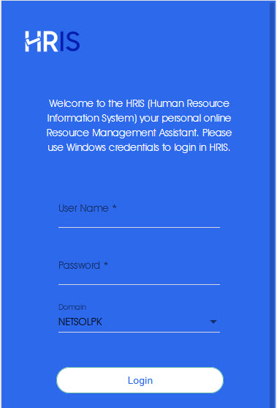
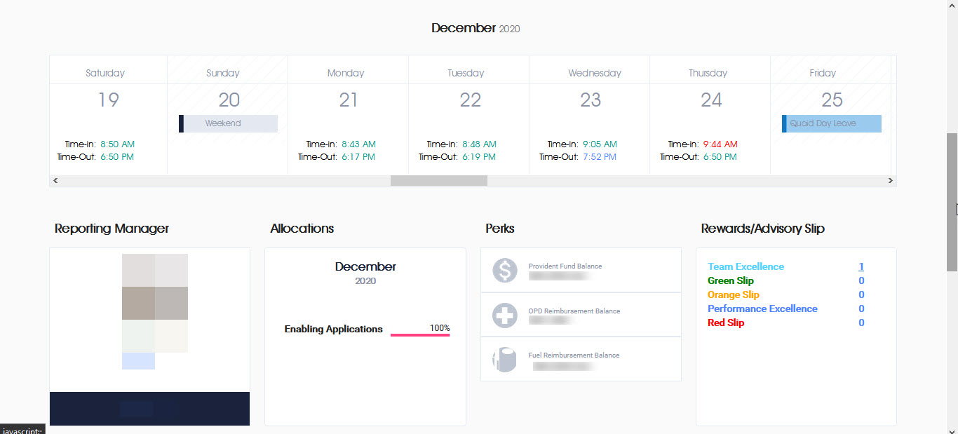
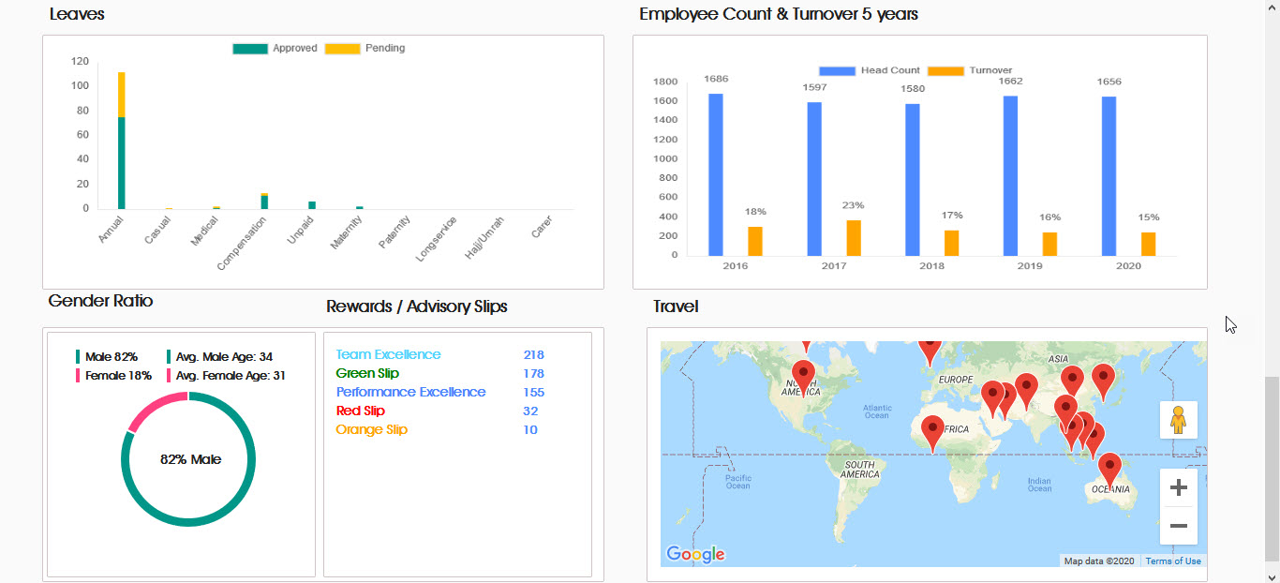
Network Service Desk: (Ticketing System)
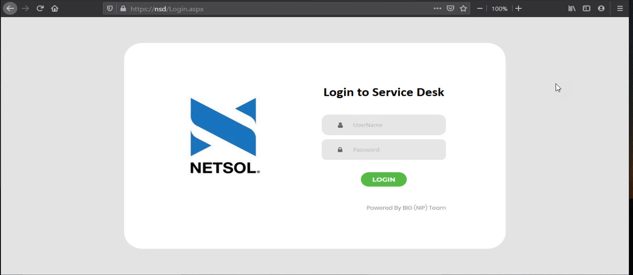
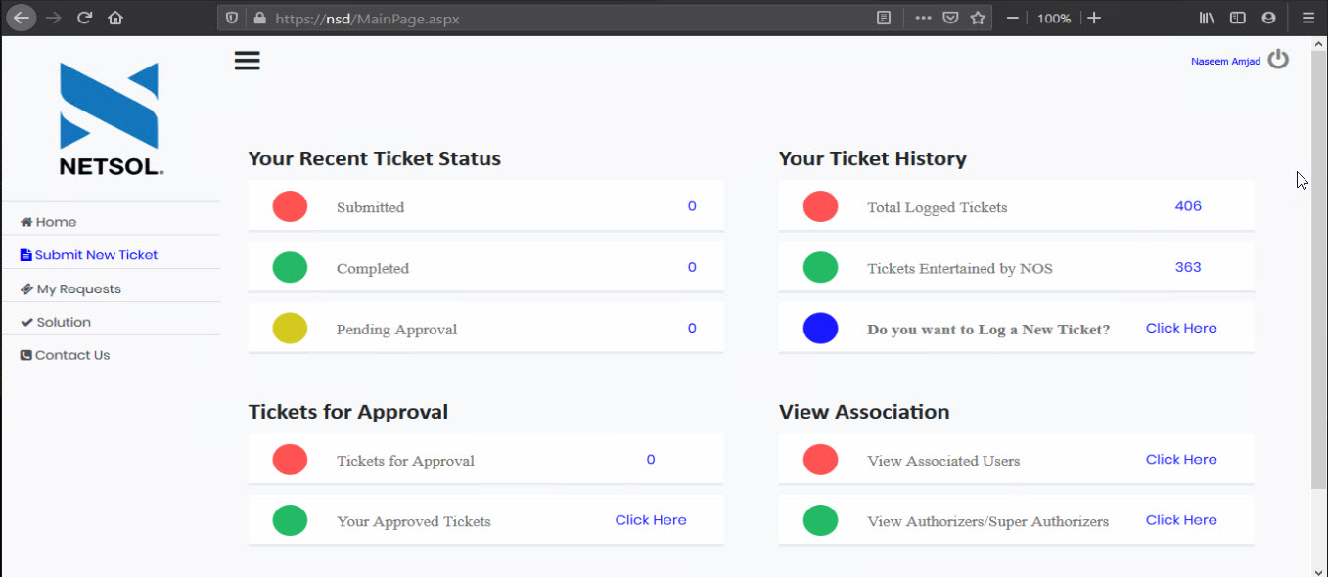
Jira IssueSync Admin: (DB Portal)
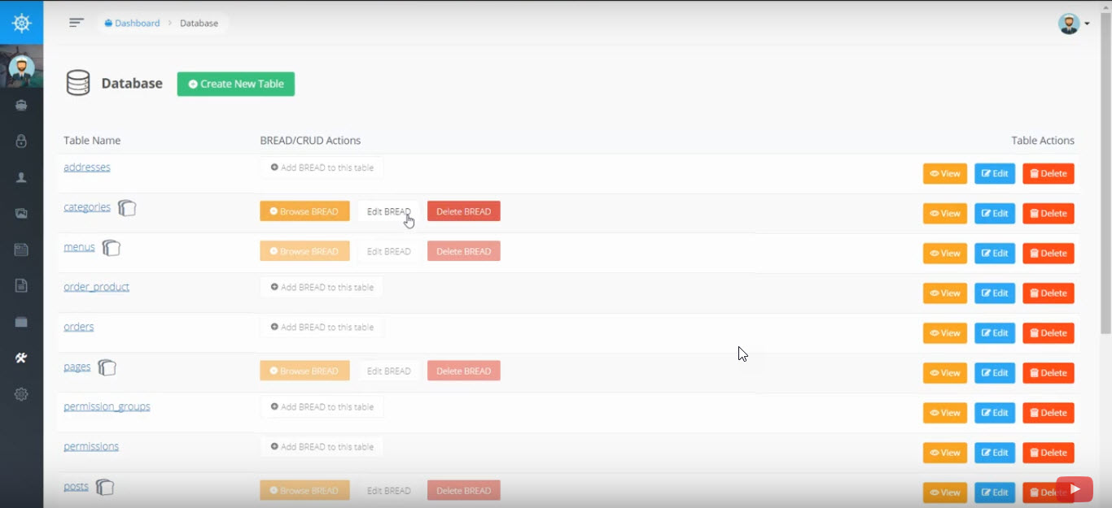
RideNShare: [Car Pooling App] (ASP.NET, JavaScript, C#, MS SQL)
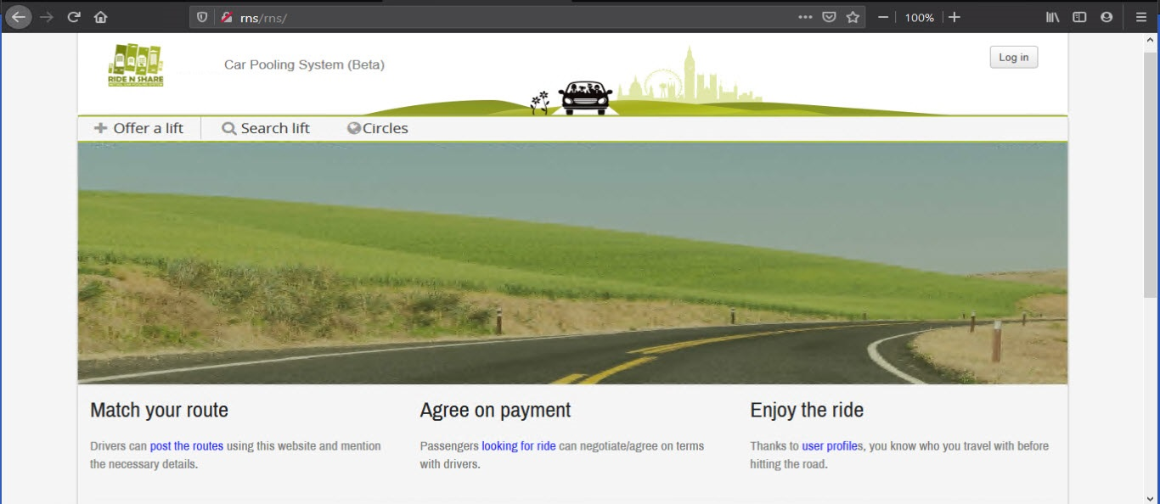
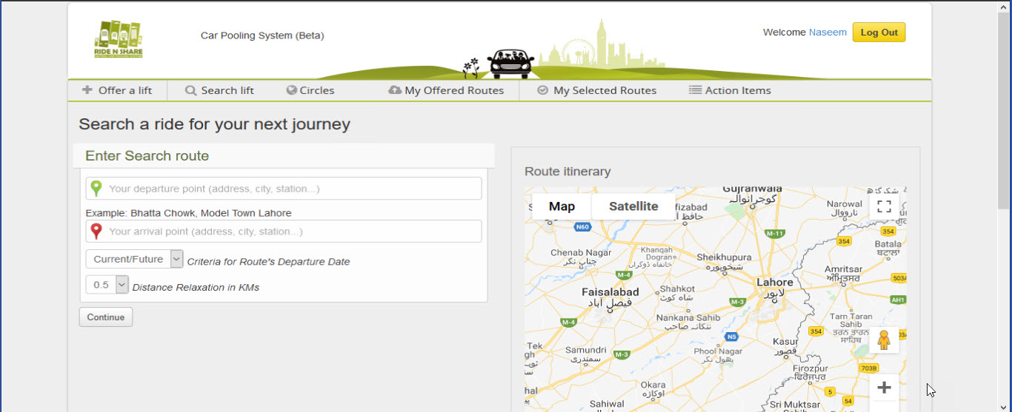
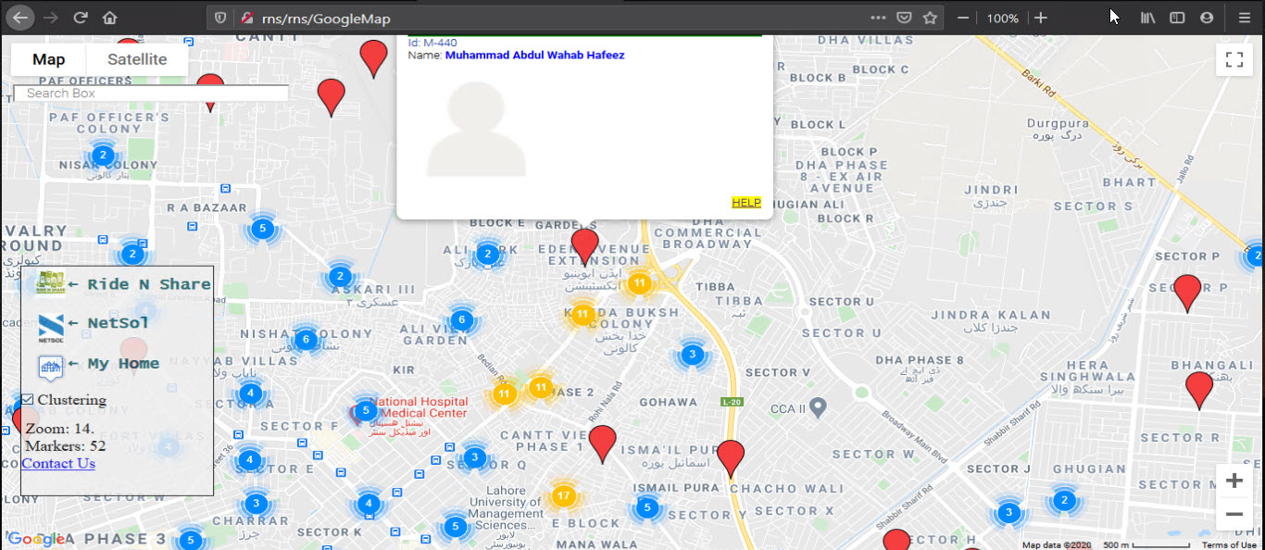
School Management System: [Web Portal] (PHP)
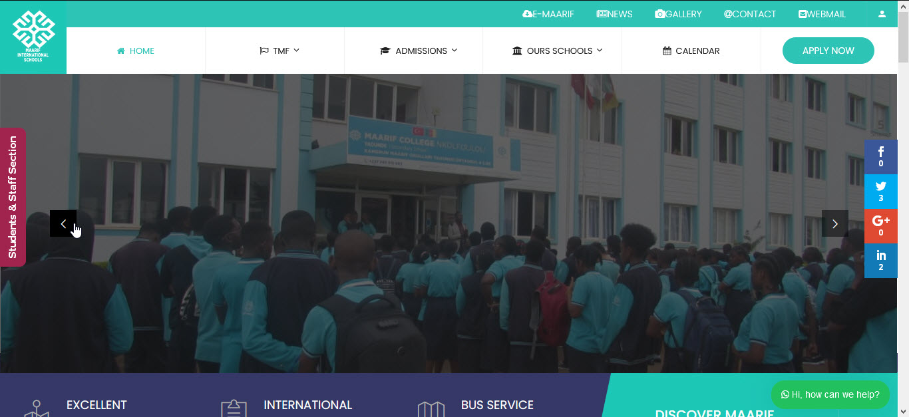
WorDoc Mobile Game: [Android Based App] (Unity)
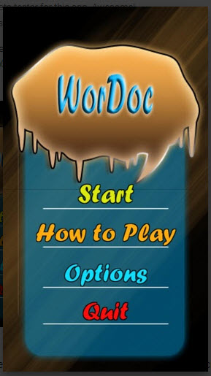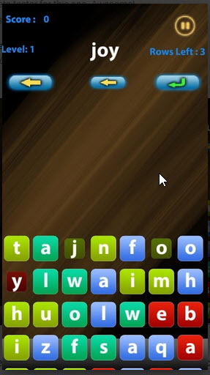
Customer Feedback System: [Web App] (ASP.NET, C#)
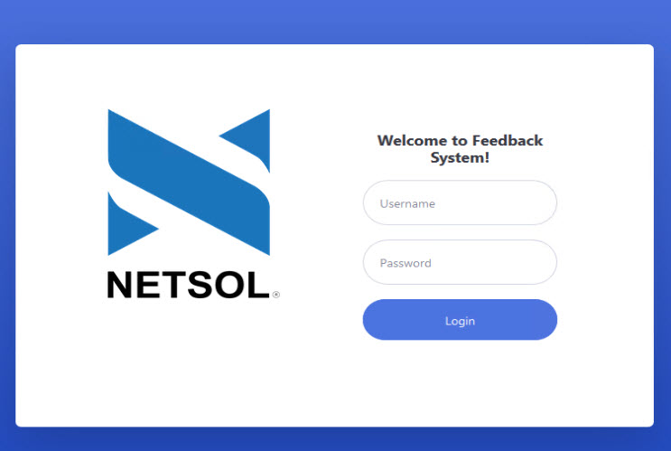
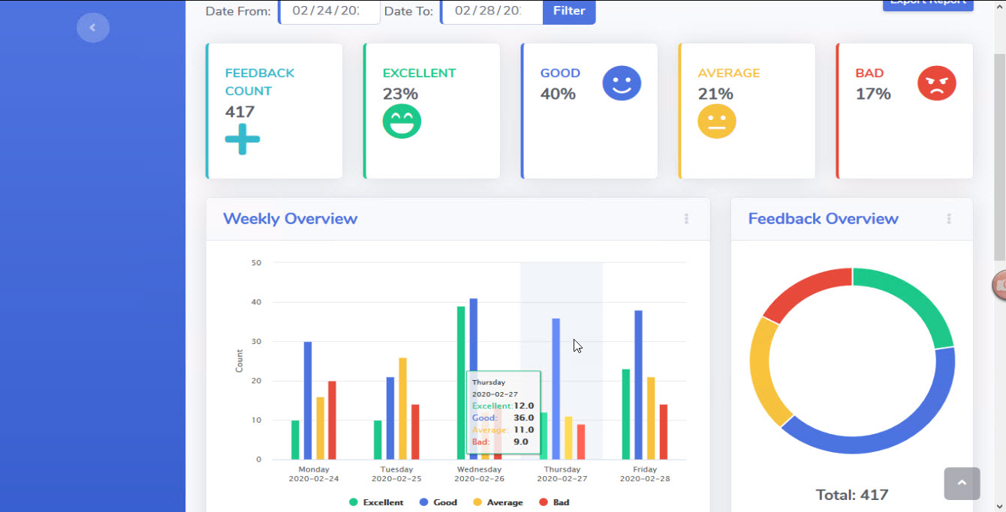
Parking Slot Management: [Responsive Web App] (ASP.NET, C#, XAML)
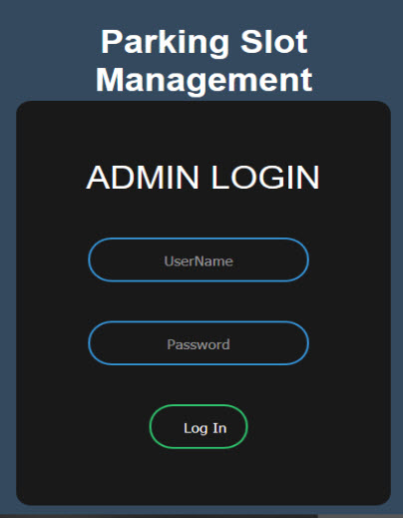
Urdu Nigar Editor: [Word Processor] [Desktop App] (C#)
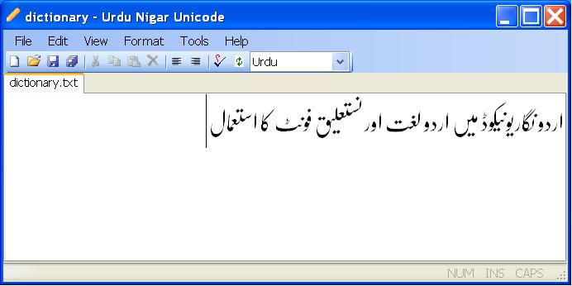
Phone Book: [Responsive Web App] (Angular, ASP Core, MS SQL)
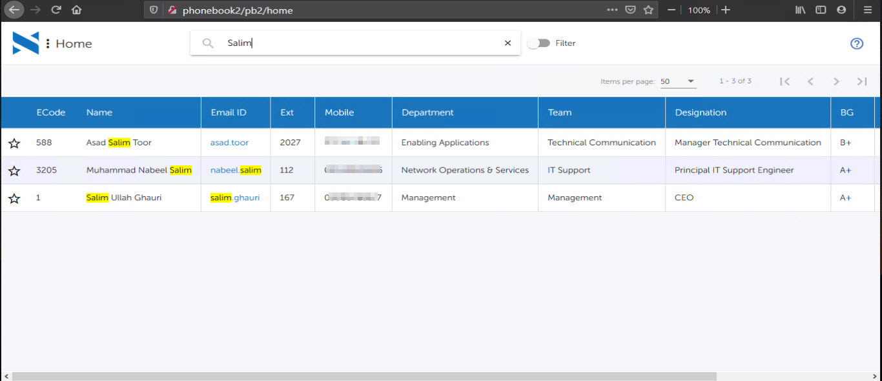
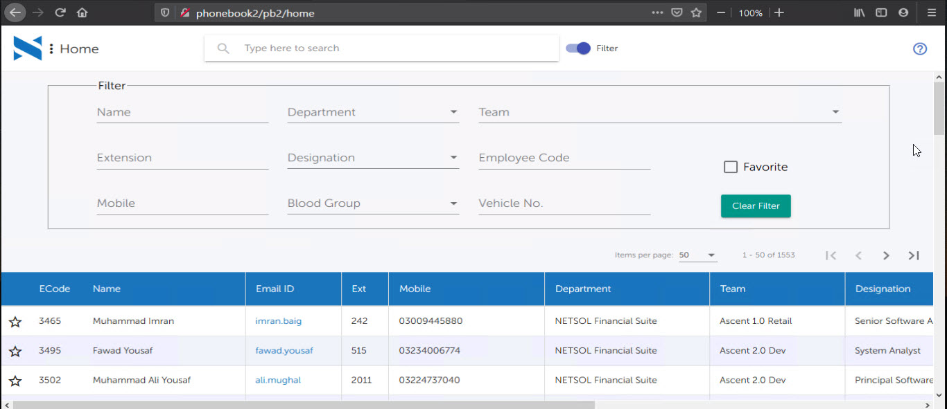
Help Desk System: [Customer Support Portal] (ASP)
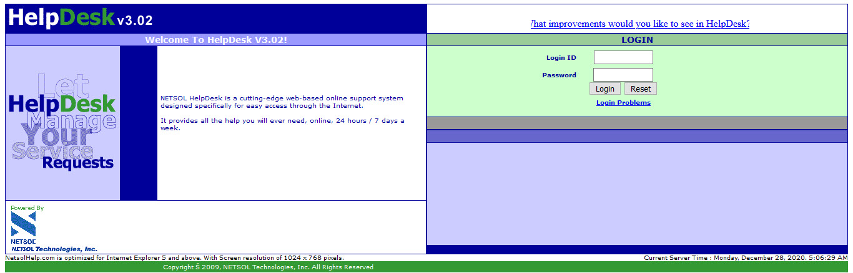

eTrainerPlus: [eLearning Game] (Unity3D)
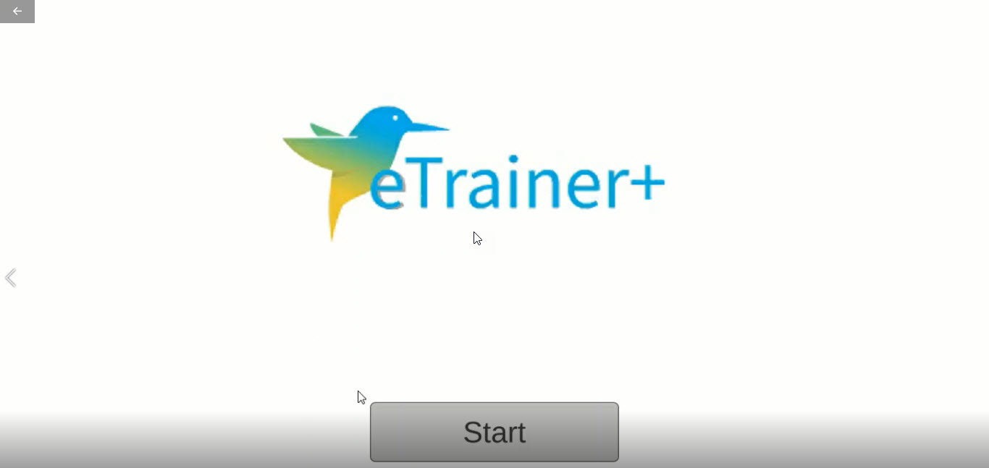
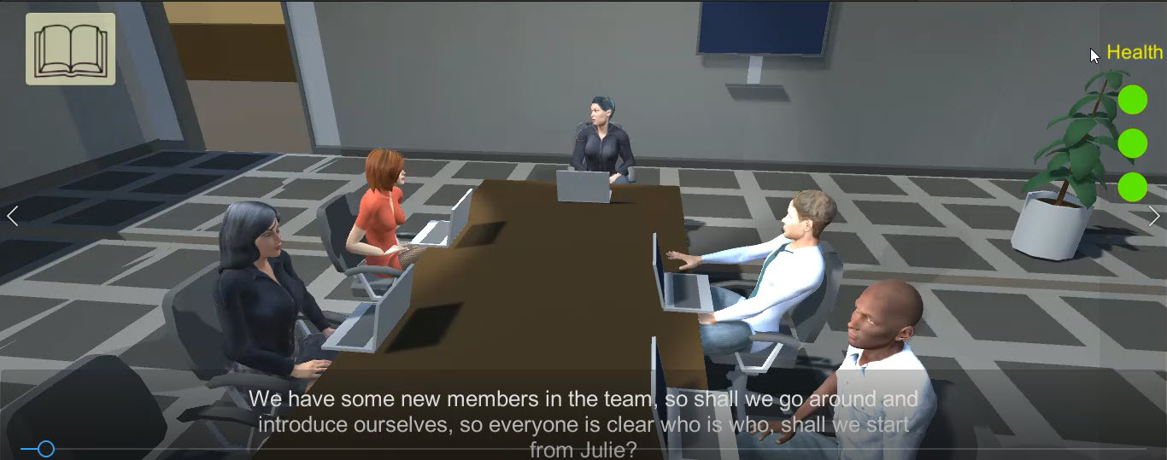
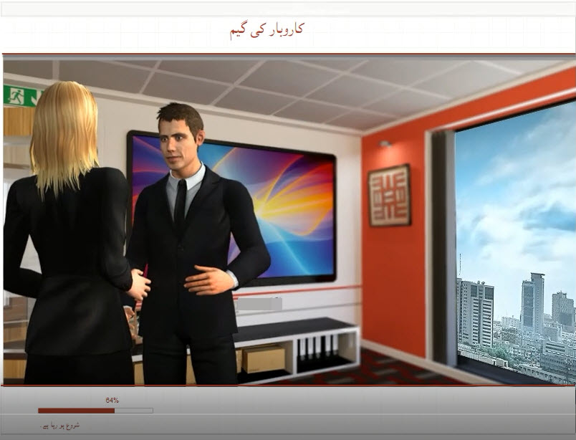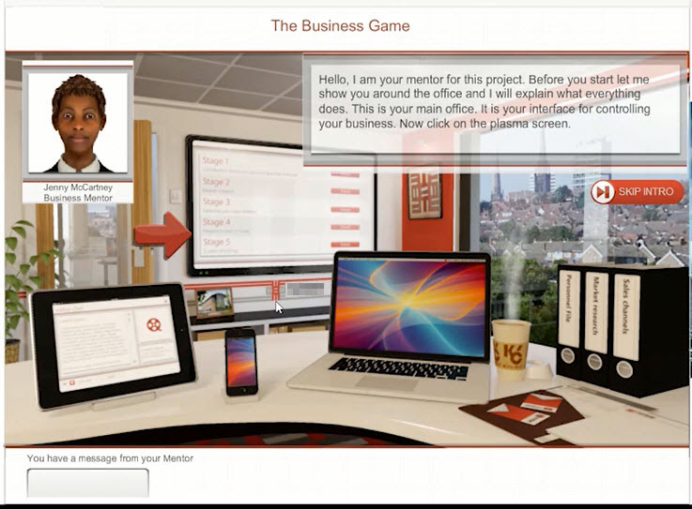
Training Game for GP: [eLearning Online Game] (Unity3D, C#, PHP)
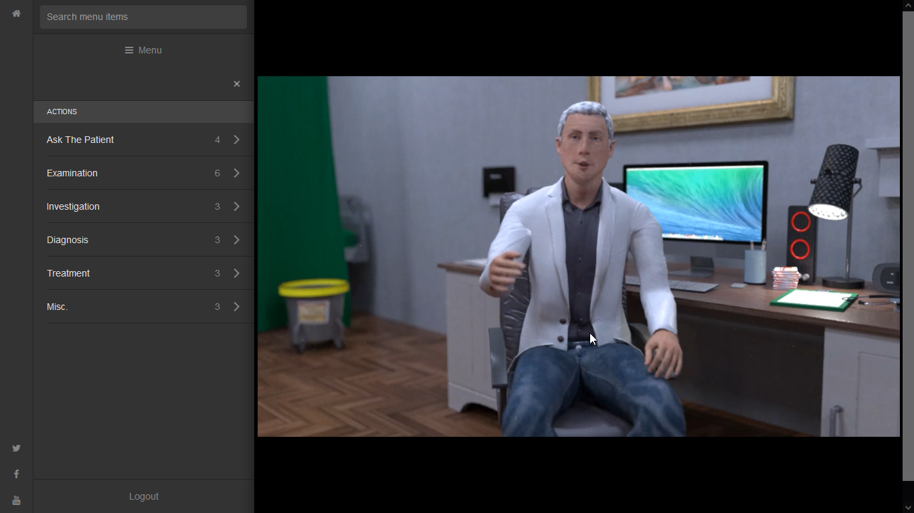
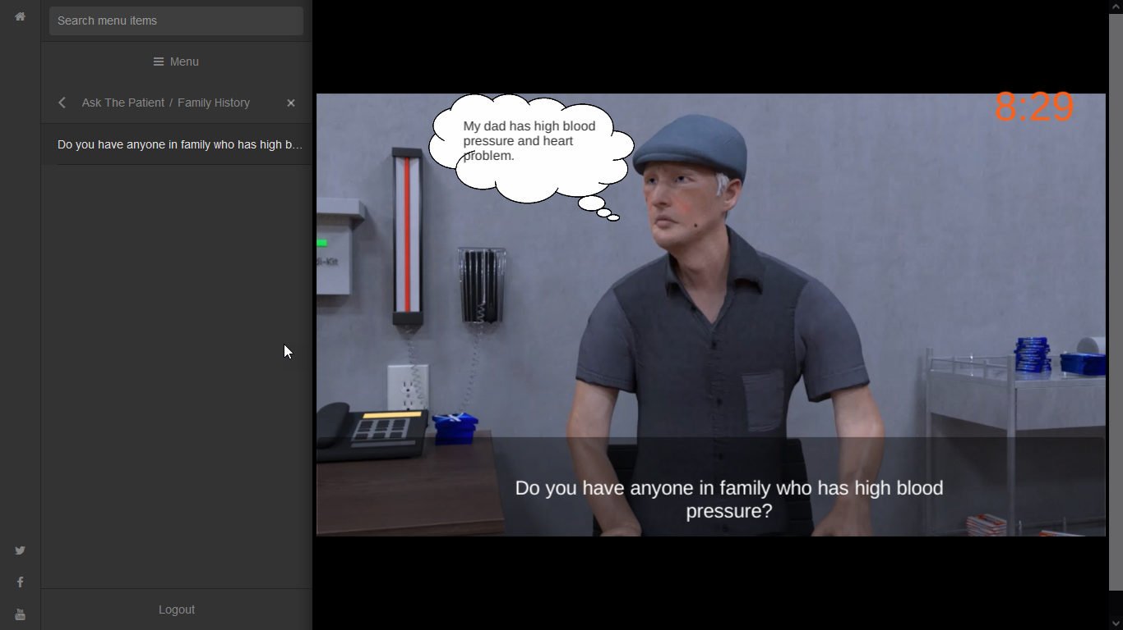
3D Configurator: (Unity3D, C#)
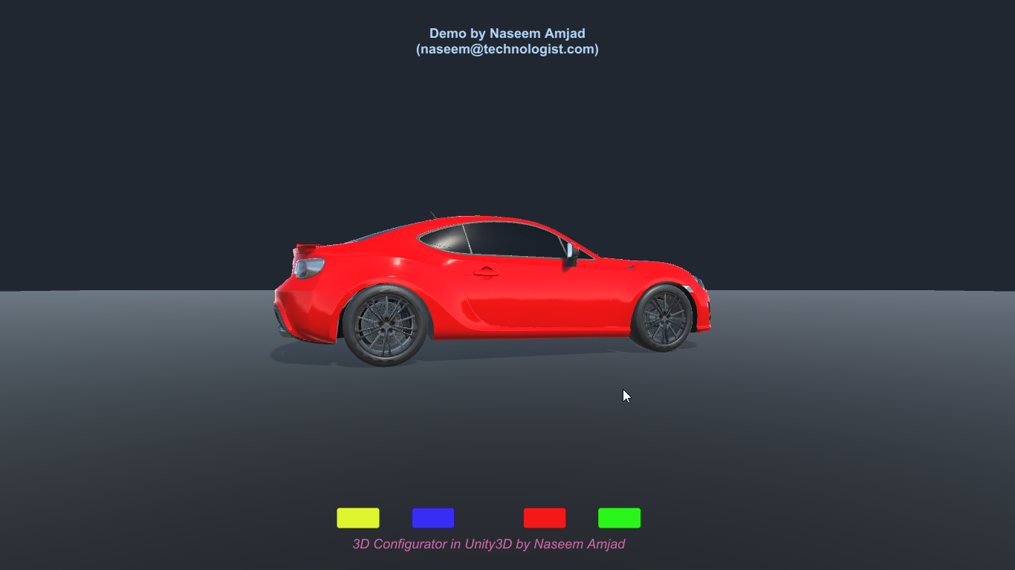
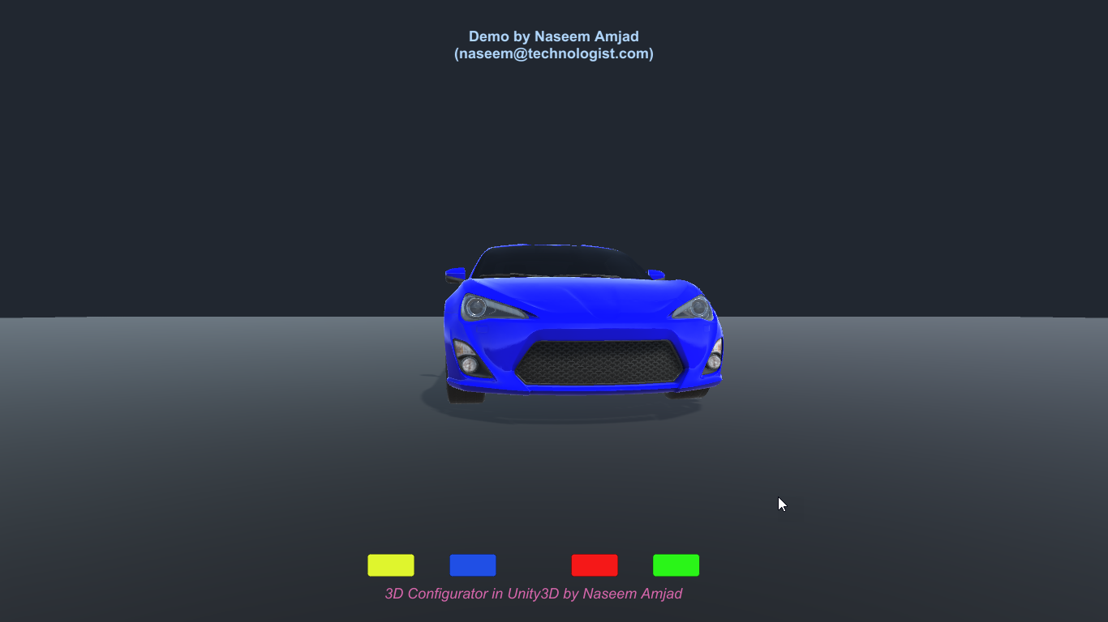
FireFox extension: [WebBrowser Plugin / Addon] (JavaScript, API)
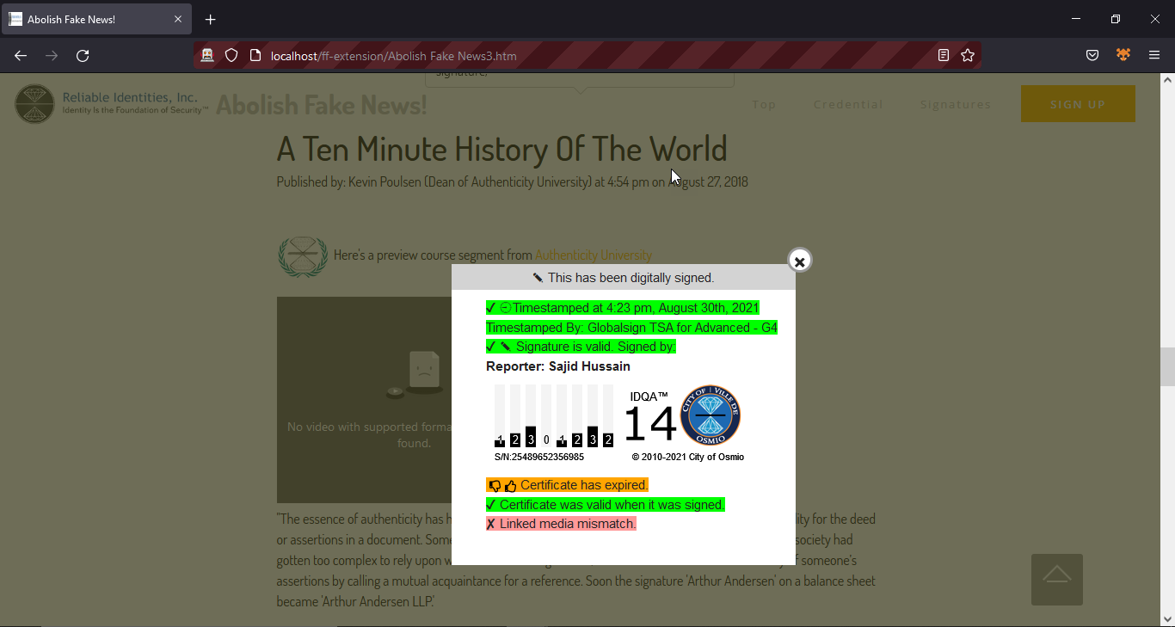
Python Script Runner: [Web Based Controller] (Python)
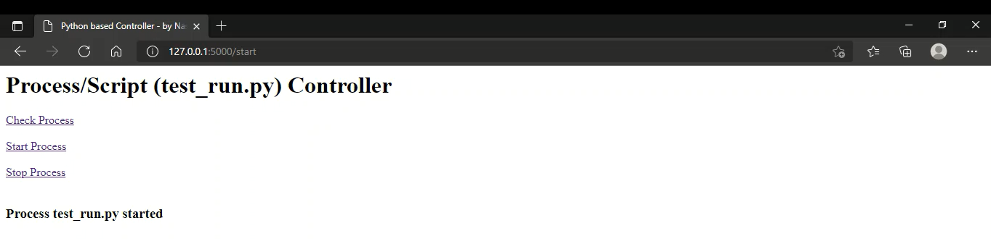
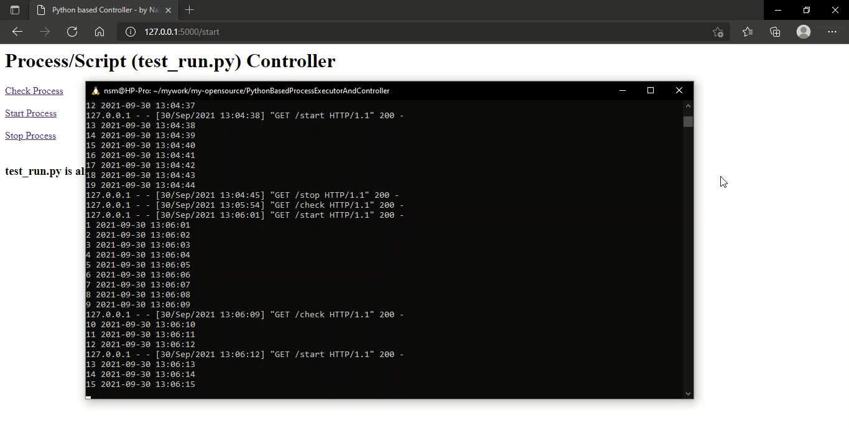
Video Uploading System: [View Video just like YouTube] (PHP)
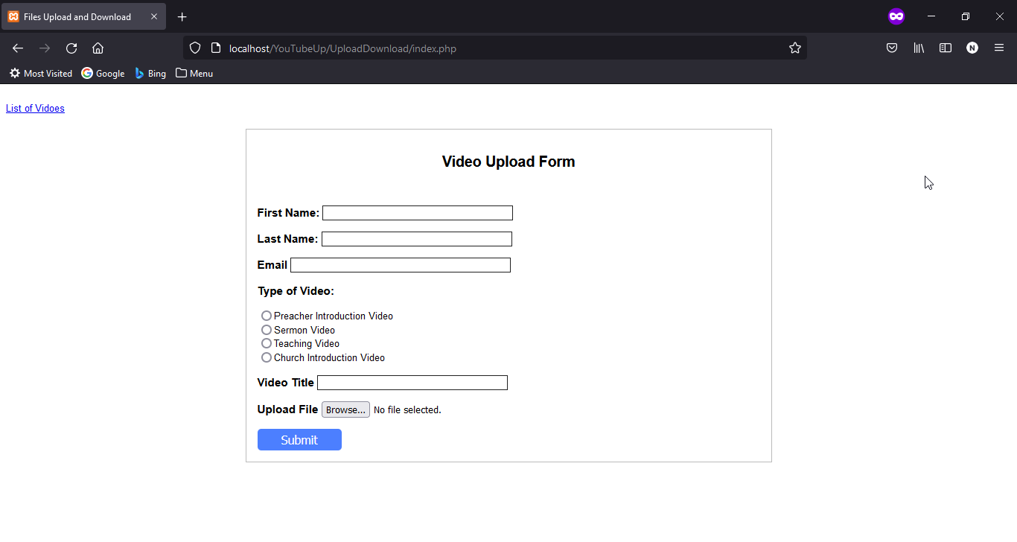
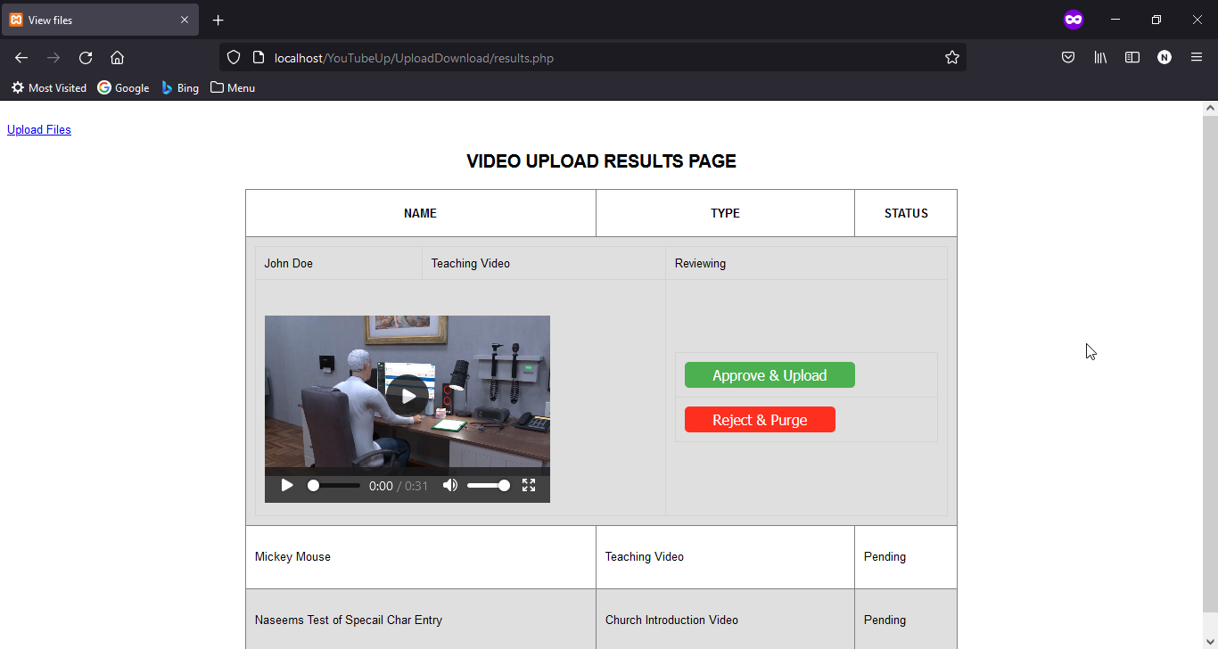
Python APIs using Django and REST Framework (Python, Django)
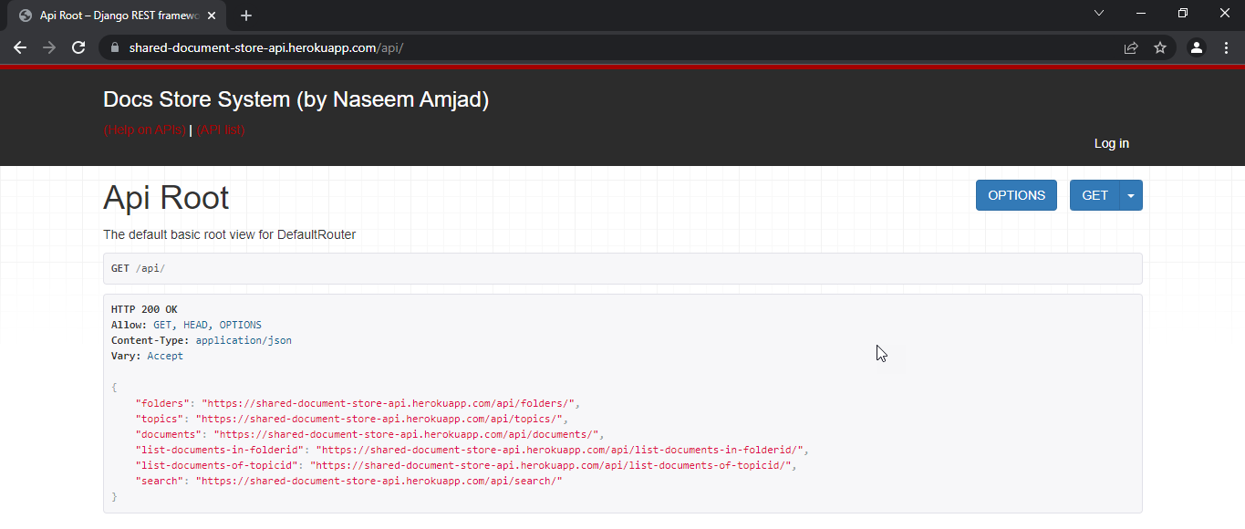

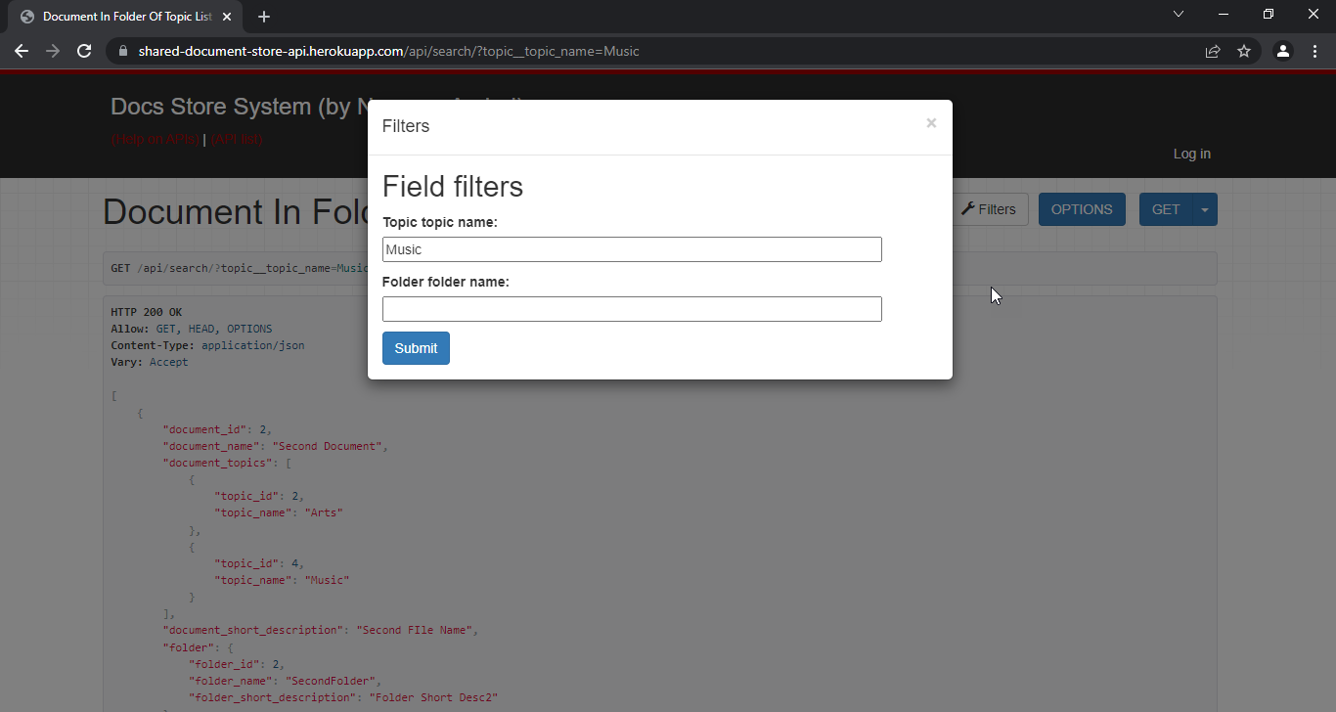
Online Quiz System (Php, MySQL)
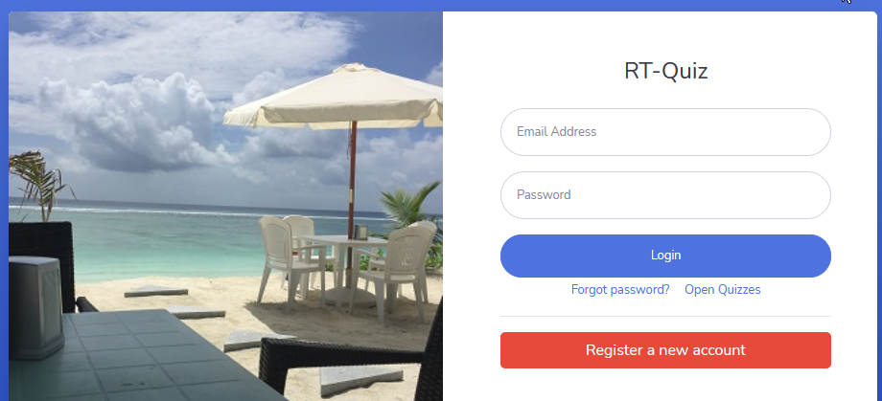
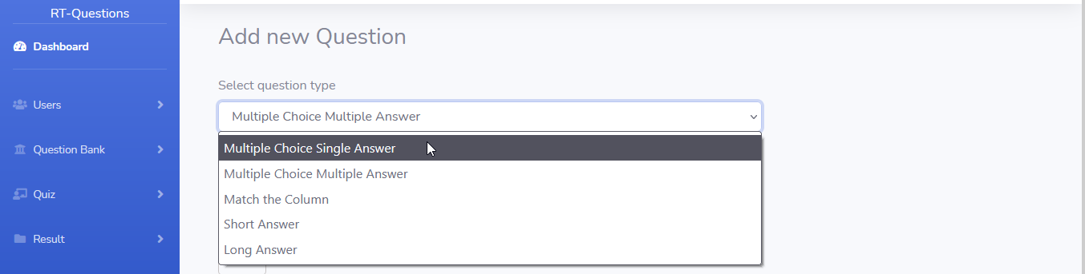
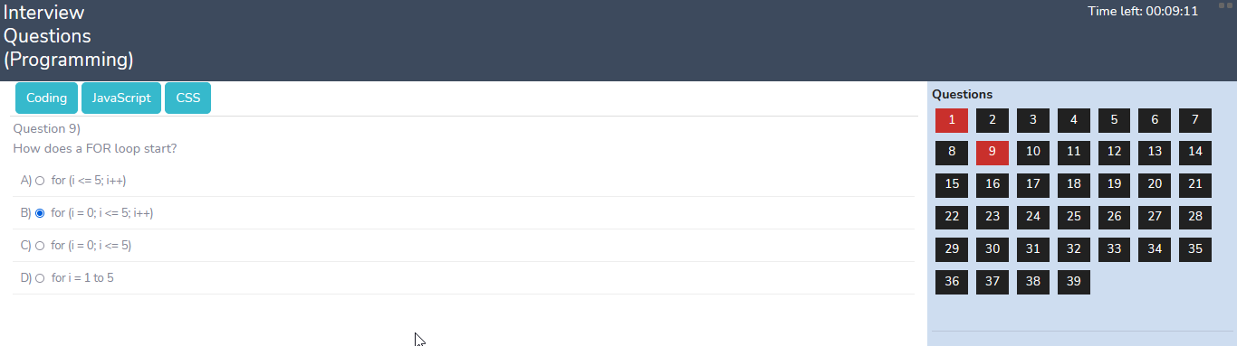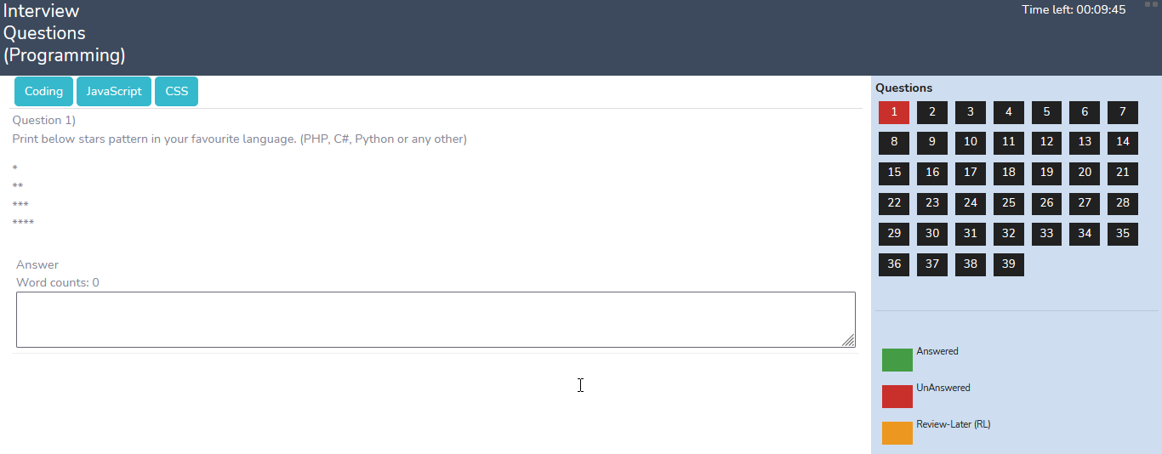
PhansiGhar: A web based game in Urdu [as well as an android game] (JavaScript, JQuery)
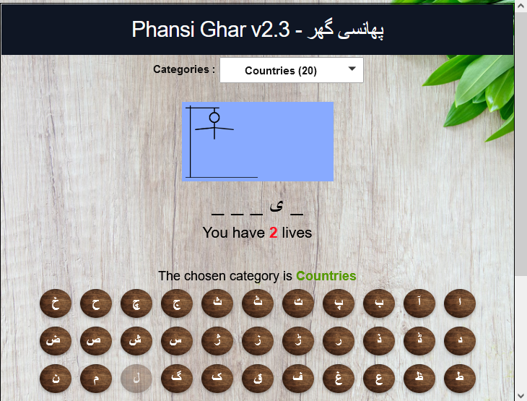
Online Neon Sign Builder (PHP, OpenCart, HTML, CSS, JavaScript, JQuery)
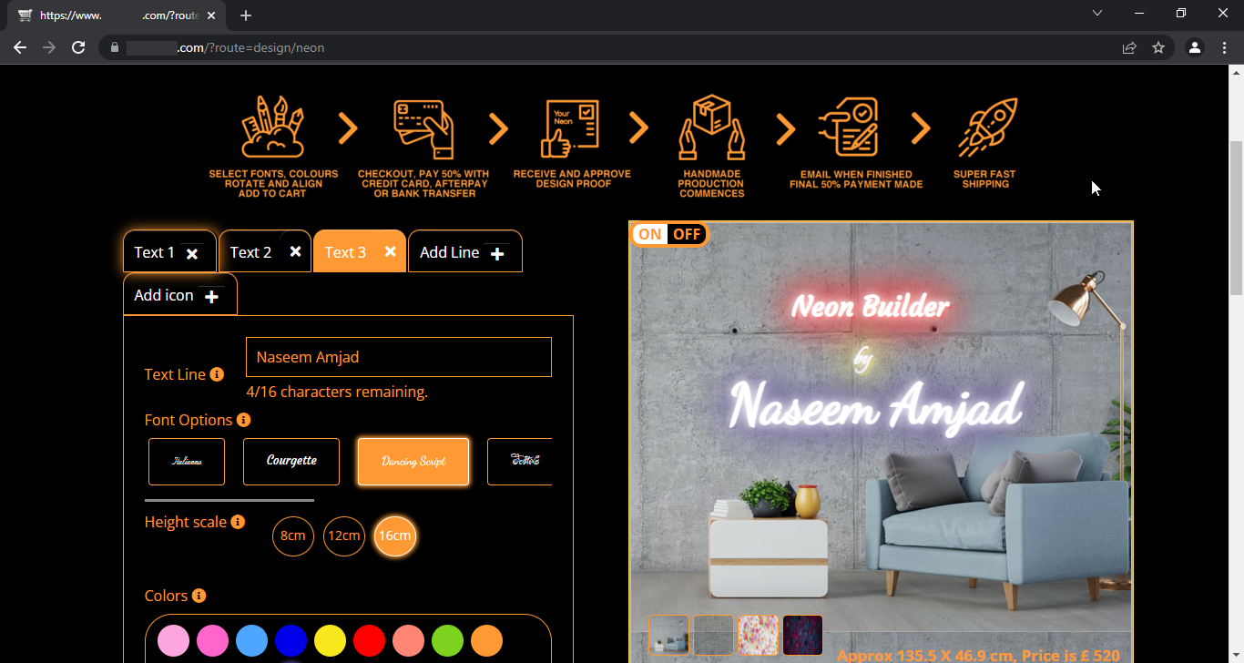

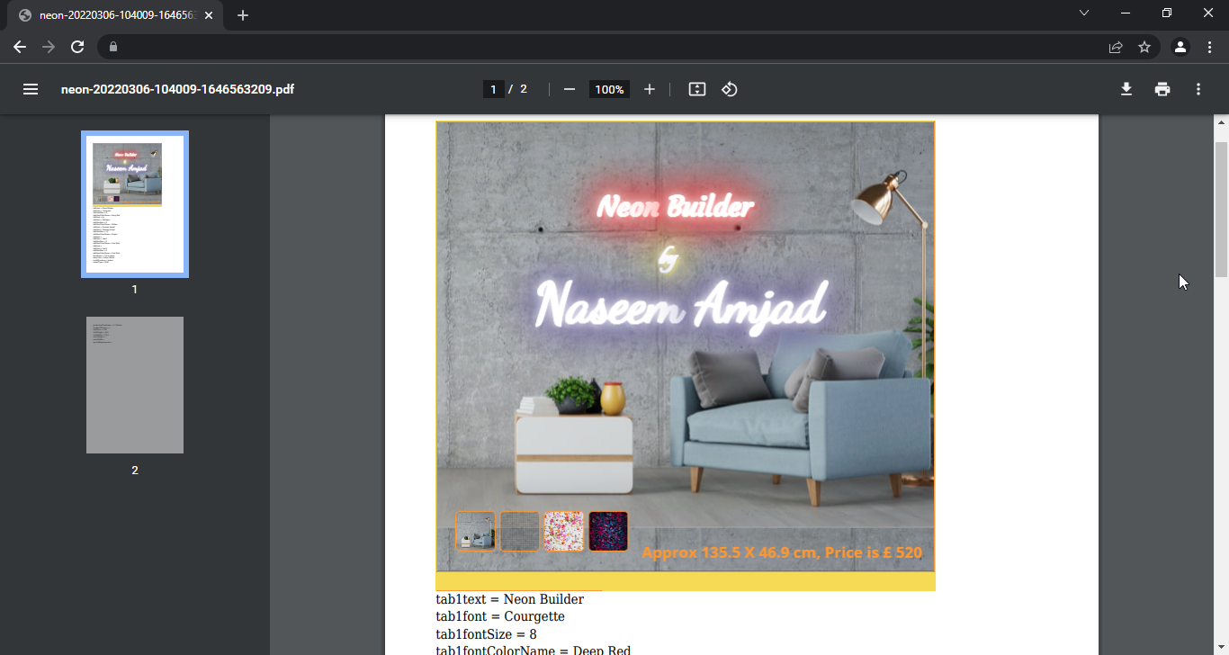
Bionify: Bionic Reader Extension for WebBrowsers (JavaScript)
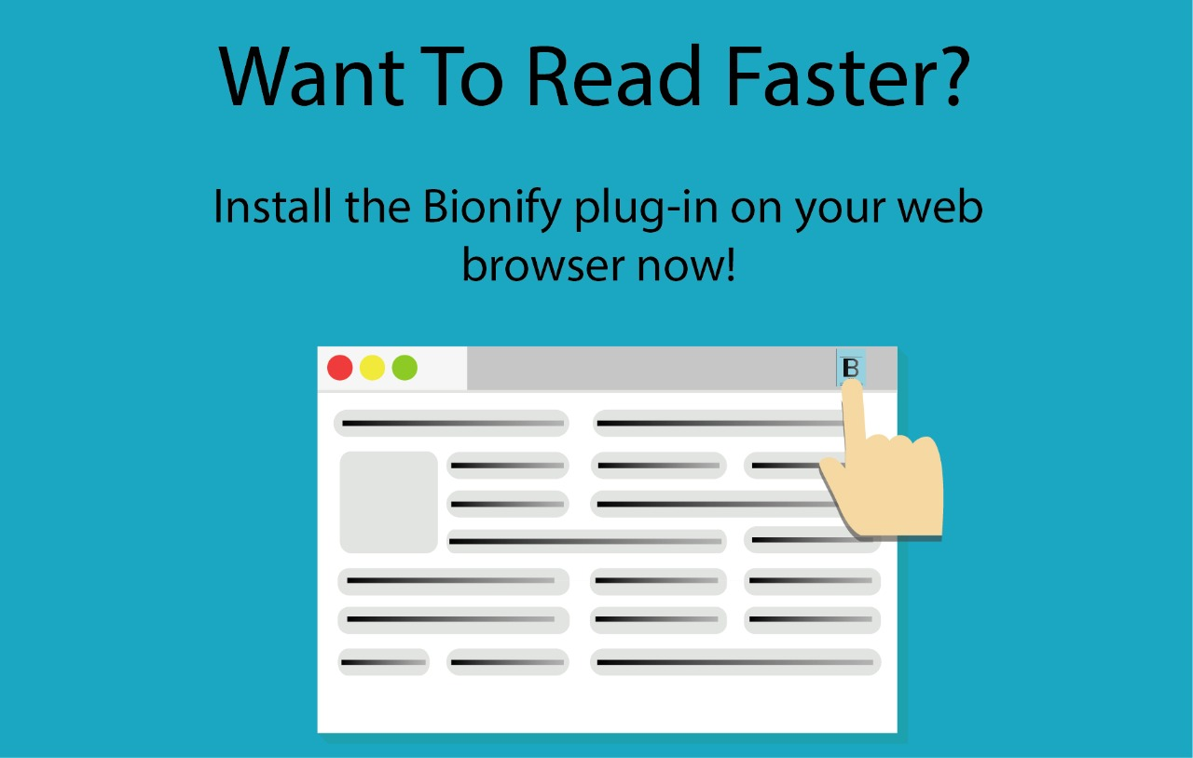
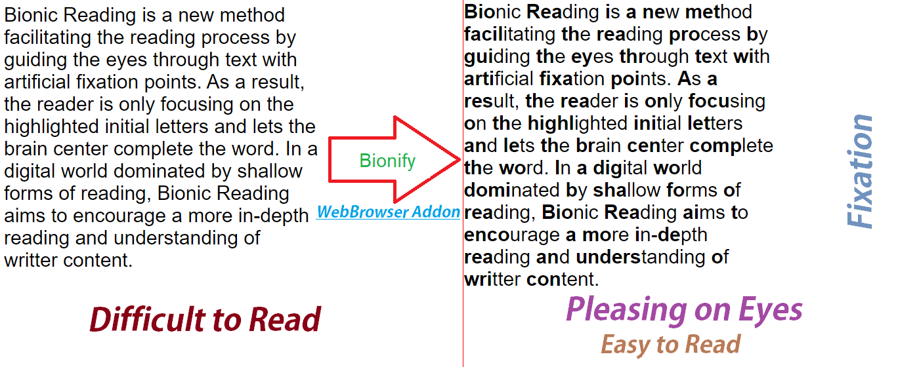
Google Apps Script code to automate a Gmail tasks (Google Apps Script)
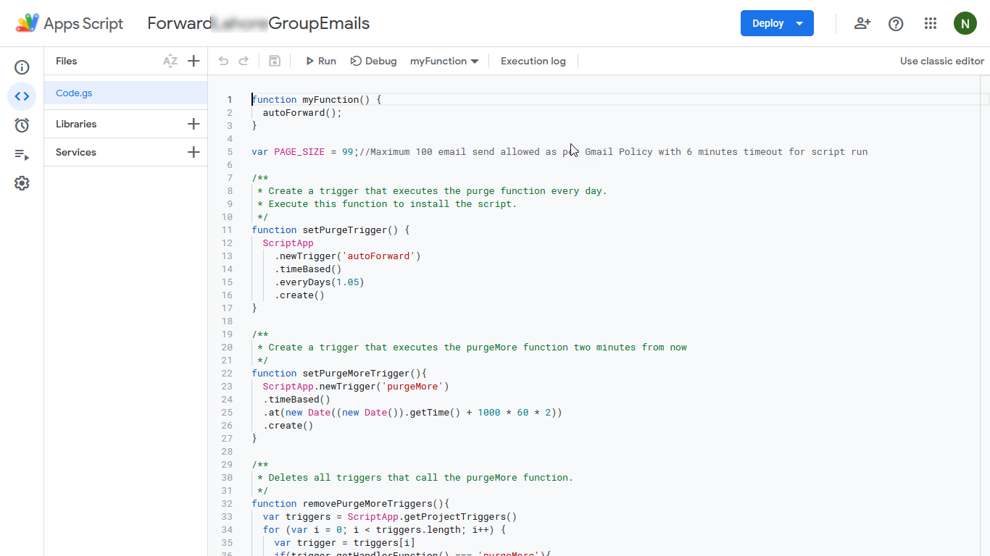

Just-in-Time Learning App (Python, Django, Postgresql, RabbitMQ, Elastic Search)
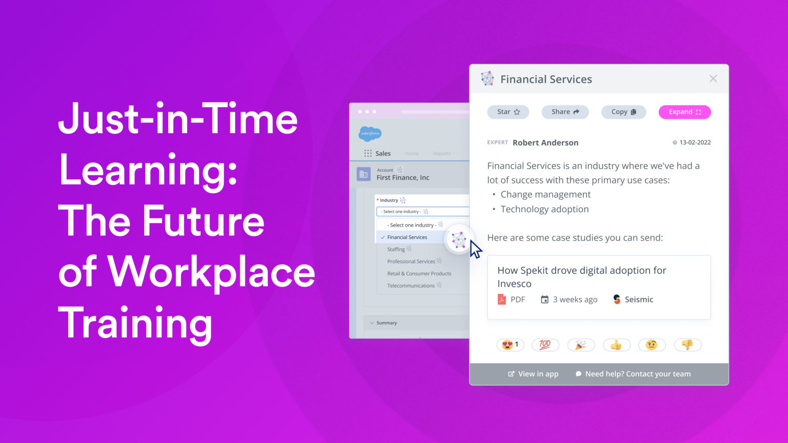

Chrome Extension (JavaScript)
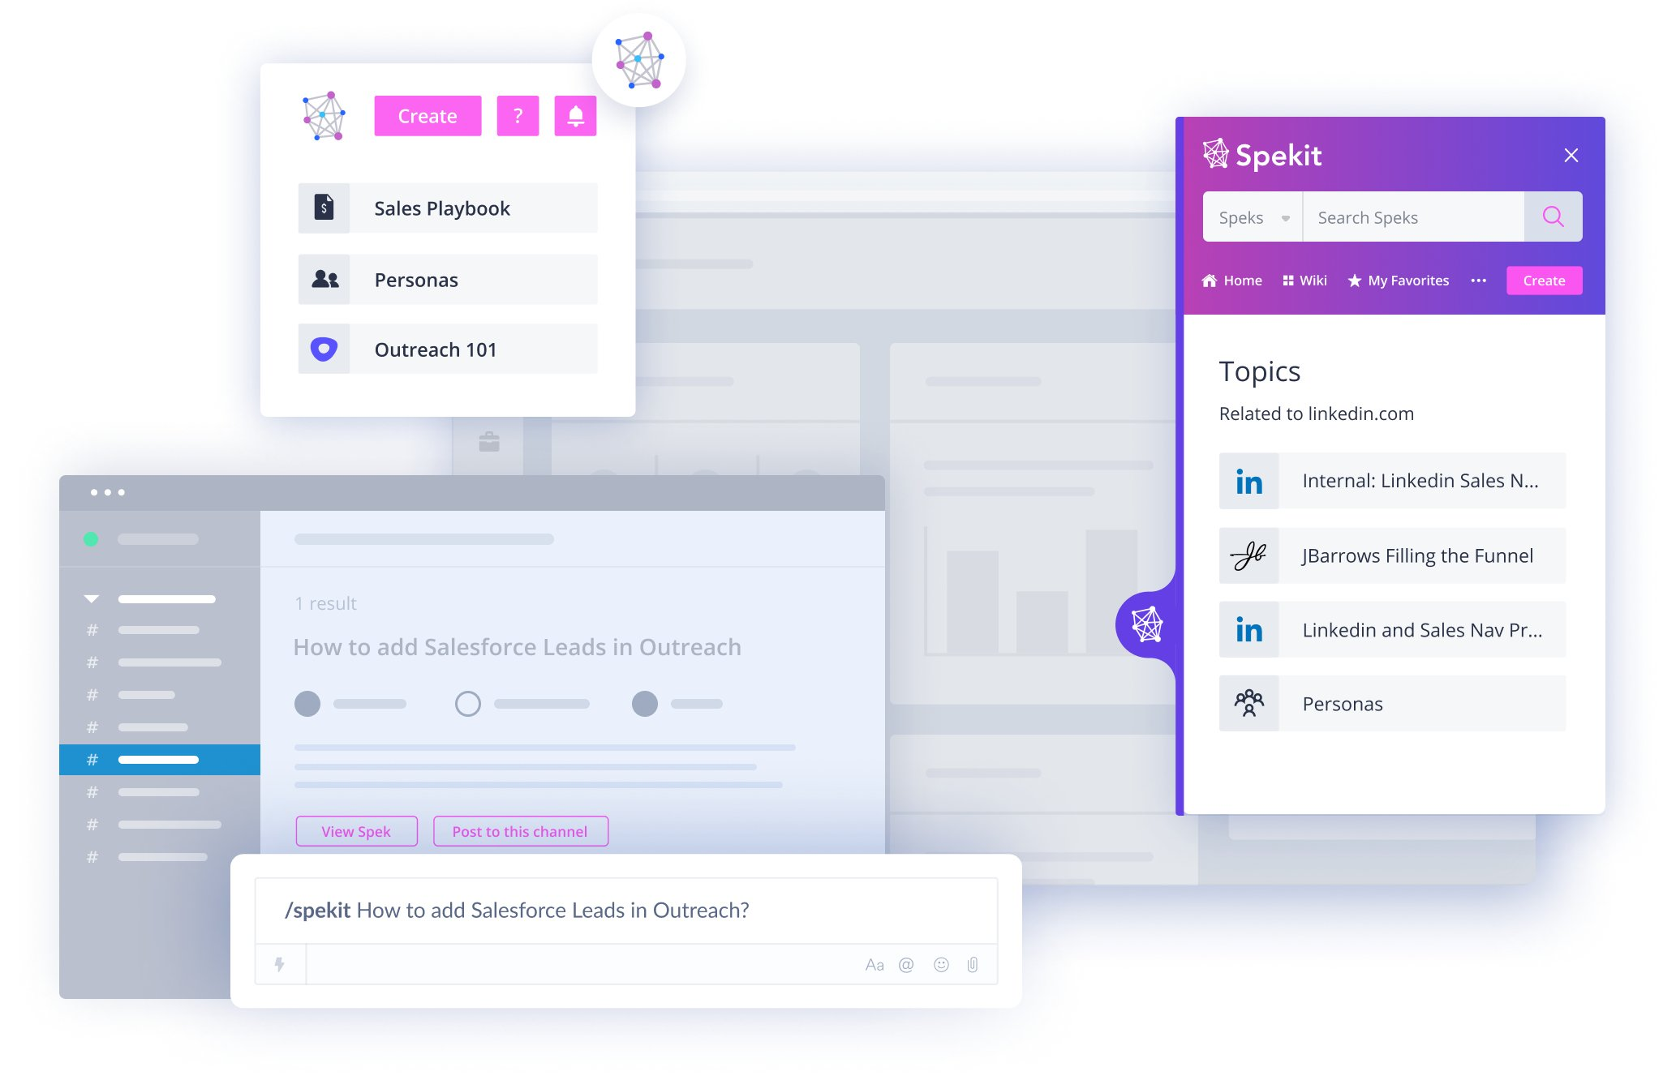
Knowledge Checks (Quiz System)
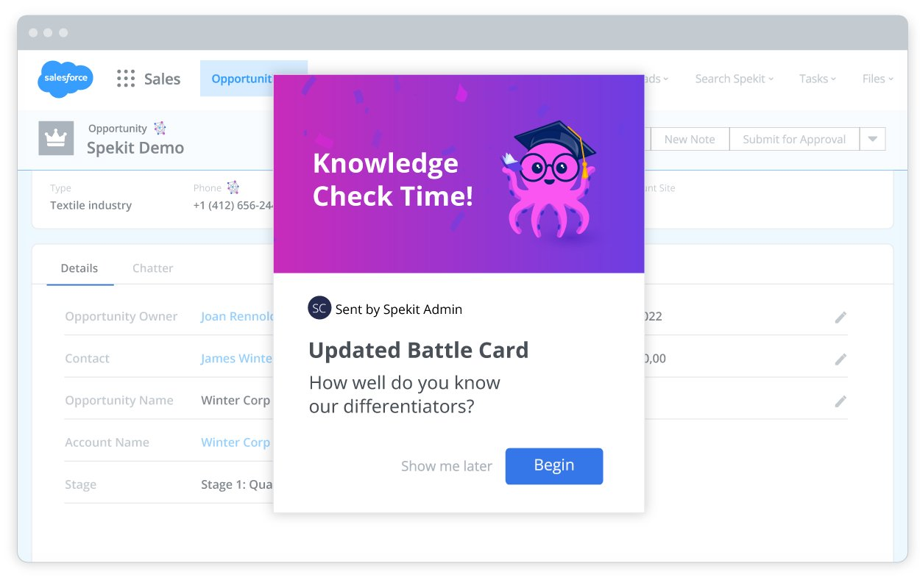
Messaging system using PushBullet: (Python, PySimpleGUI, Desktop)
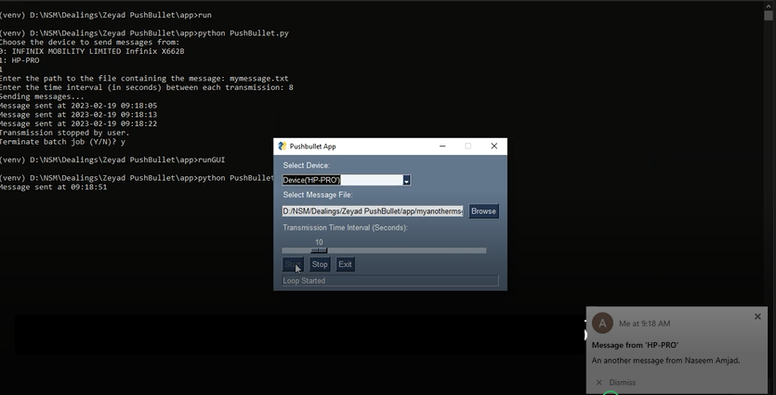
ChatGPT integration with Google Text to Speech and Speech to Text APIs (using Python)
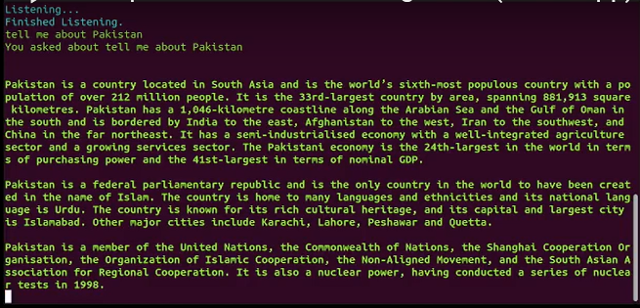

AI Work (Using Python)
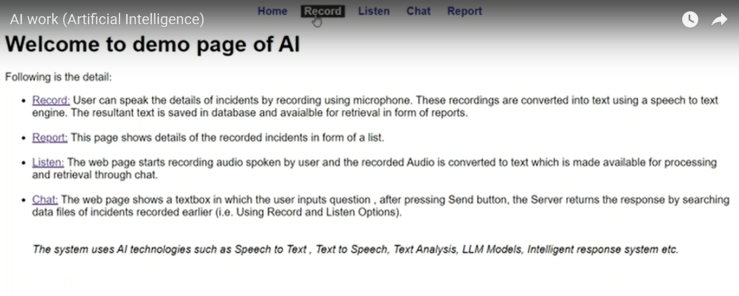
Fill Online Forms using Speech
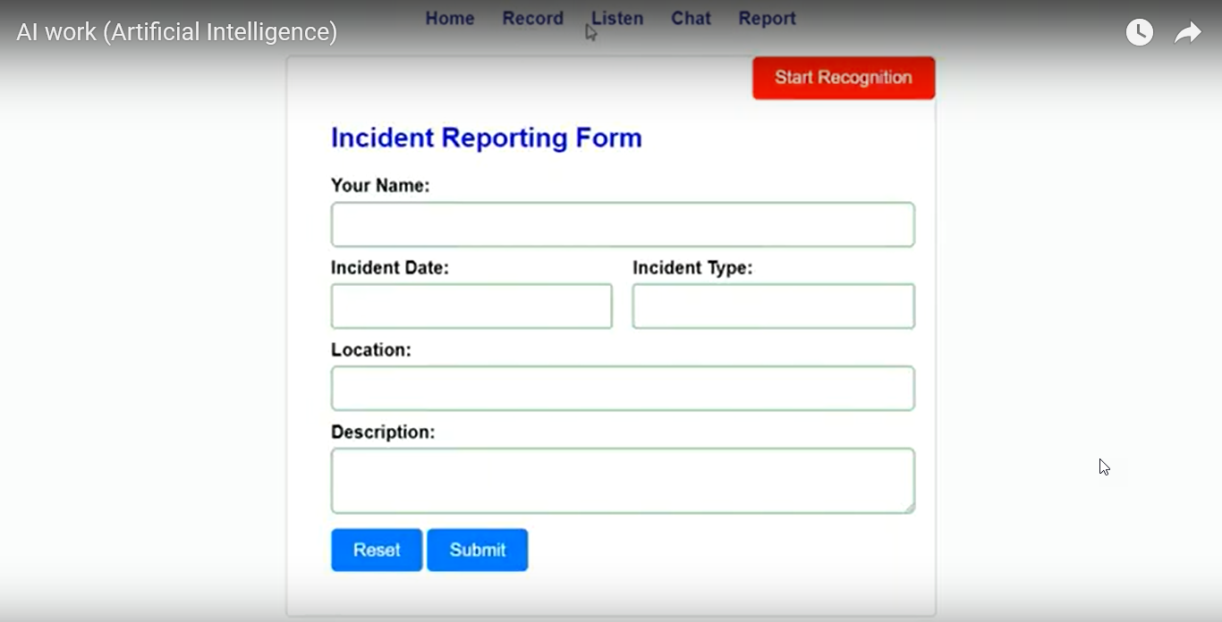
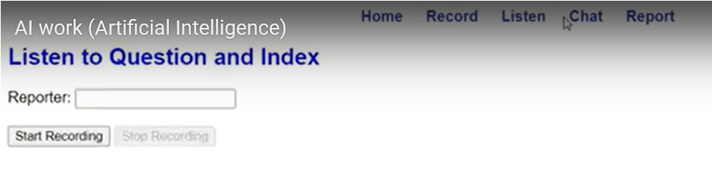

Intelligent Chat [using customized (RAG) ChatGPT] (Python, Flask, LLM, Langchain)
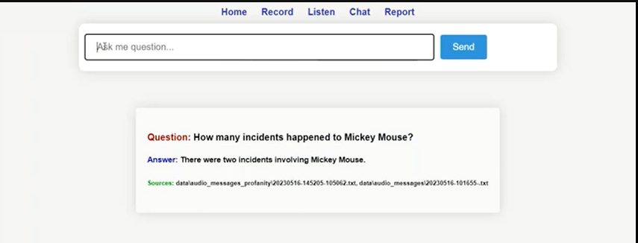

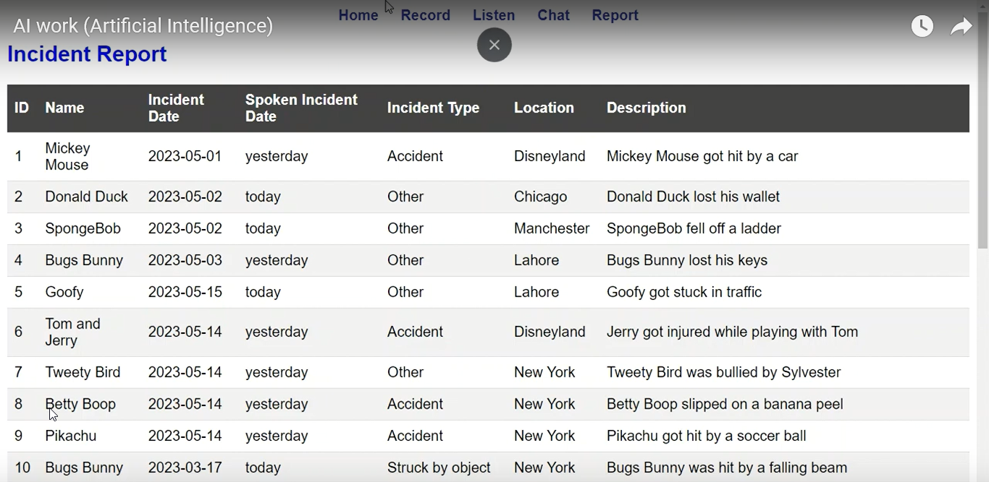
Integrating LLM with Open3D (Python, Flask)
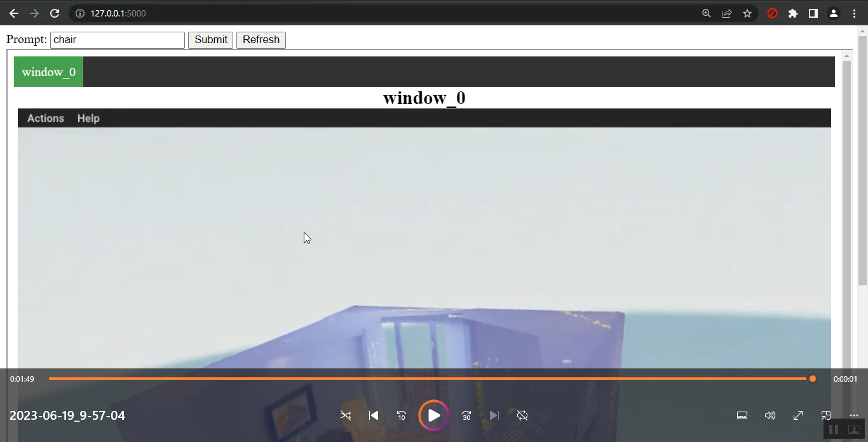

UrduBar: An addon for web browsers supports Urdu, Arabic & Persian (HTML, CSS & Javascript)
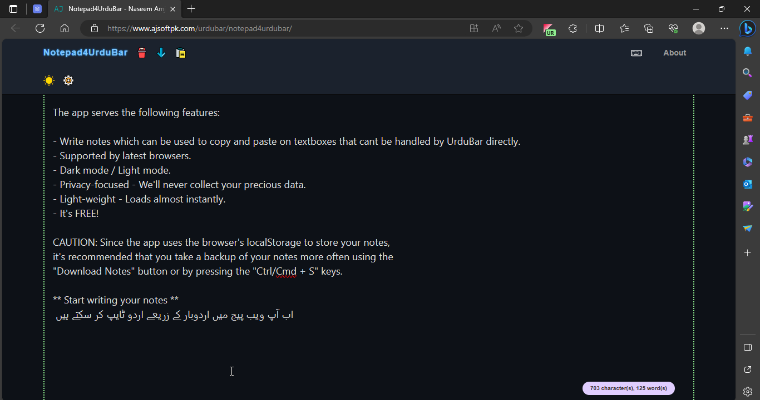

JET: ChatGPT4 AI Assistant (Python, FASTAPI, OpenAi, REST API)
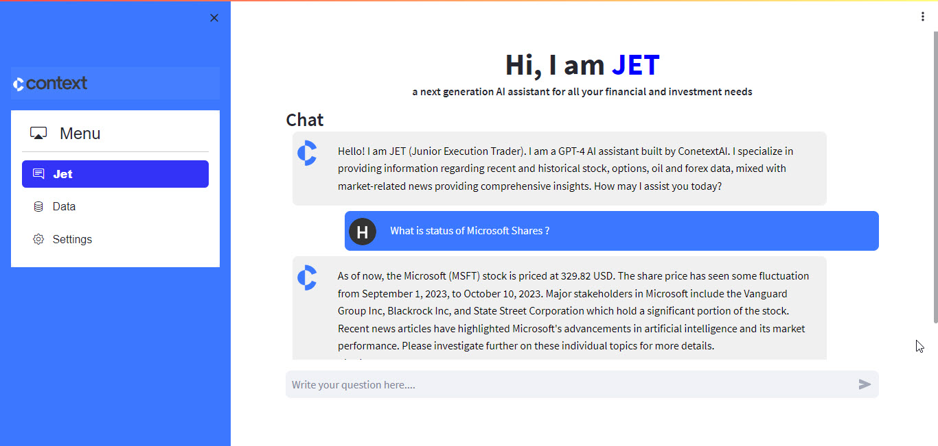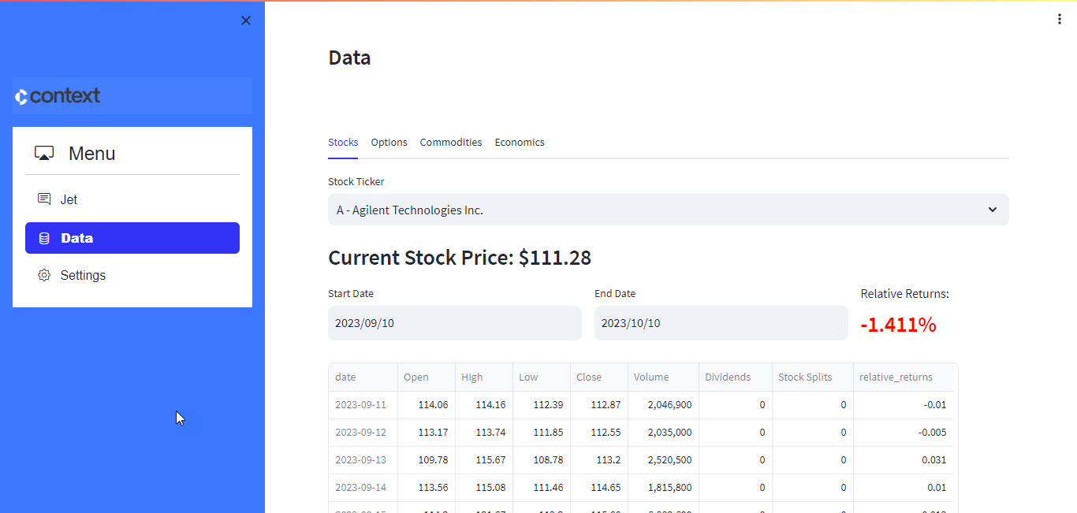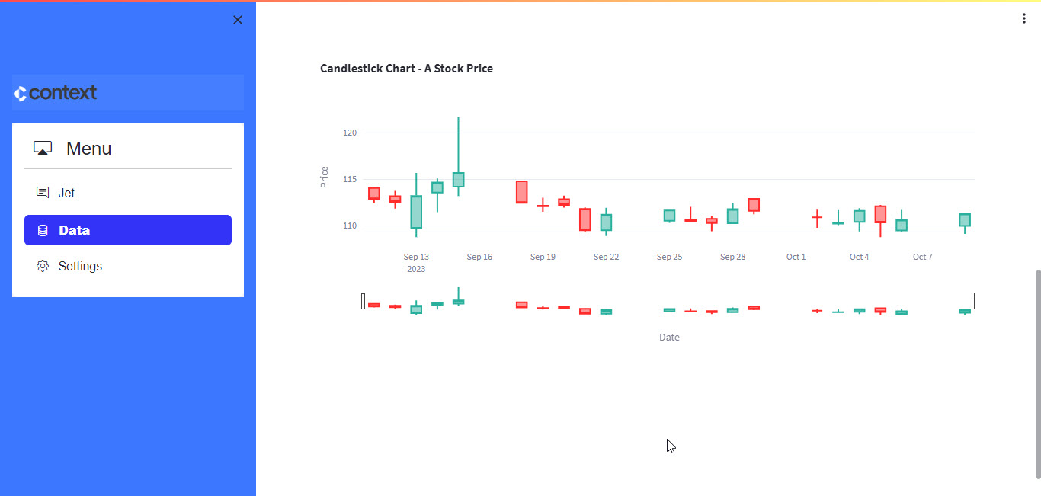
POS Reciept generation system (Python, ReportLab)
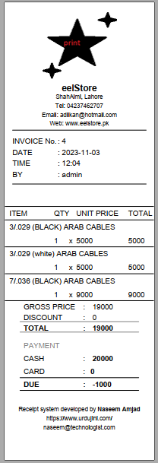

Urdu Font Manager (QT C++)
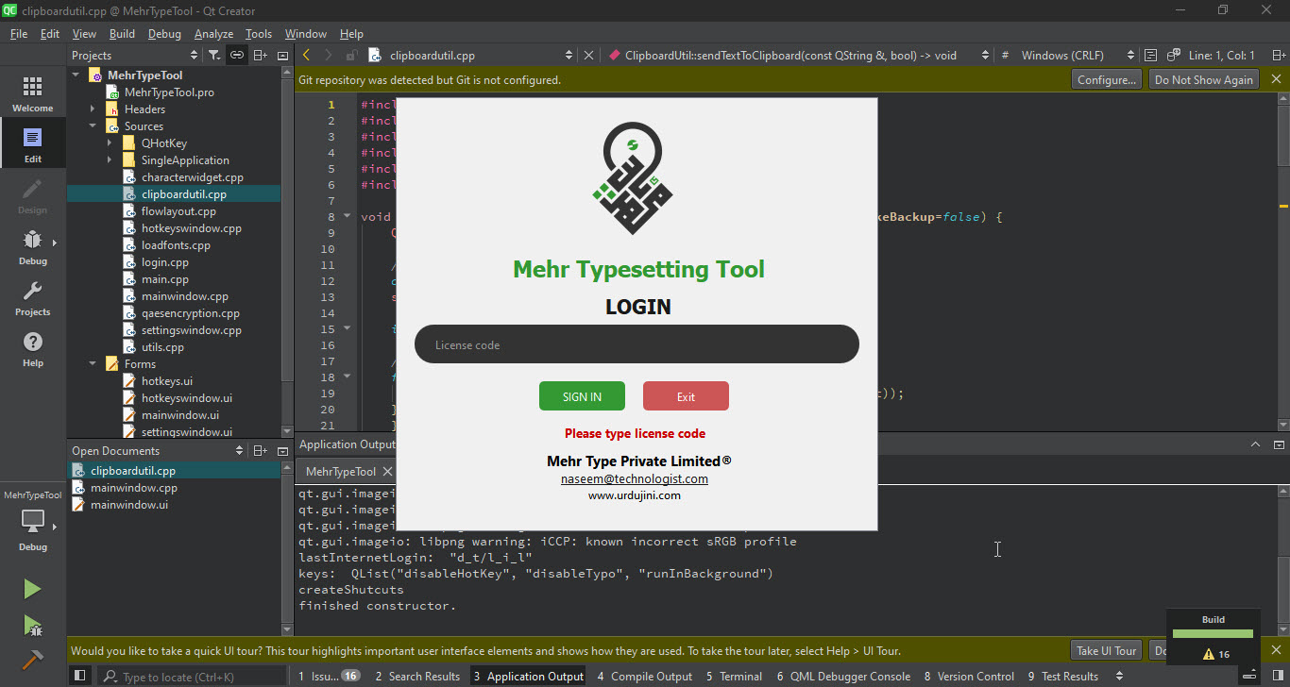

Dashboard System for Market Analysis (Data Engineering, GCP, Python, BigQuery)
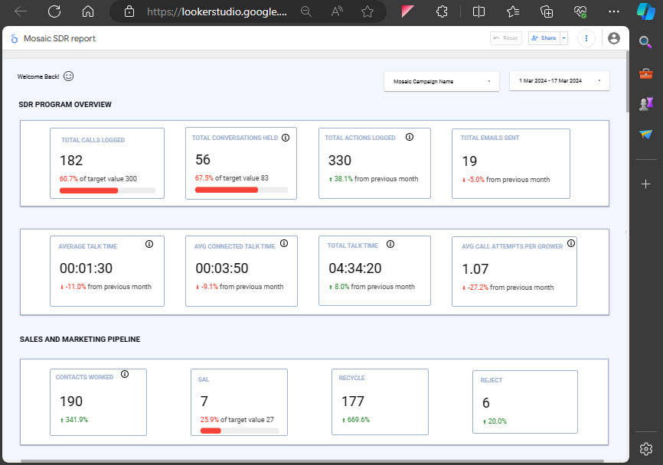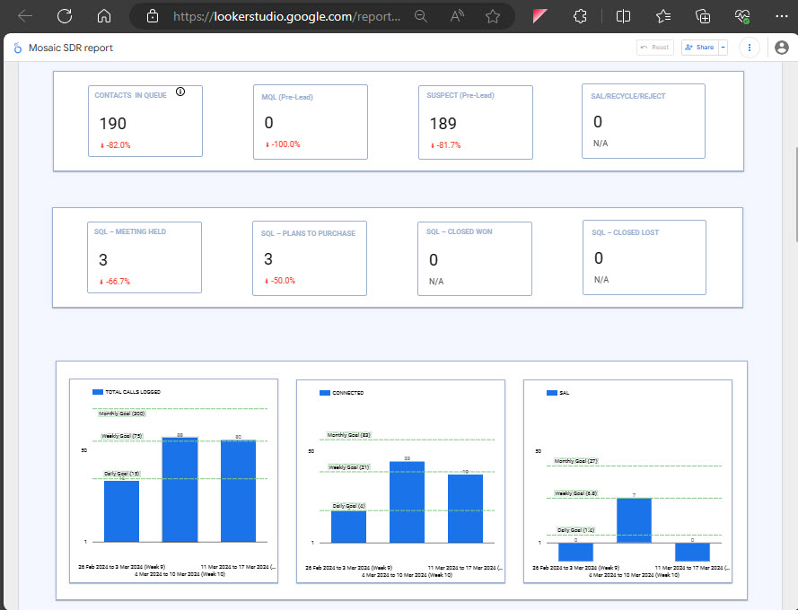

Printer Virtual Driver that converts artifacts to PDF (Python, C#, C++, NSIS Installer)
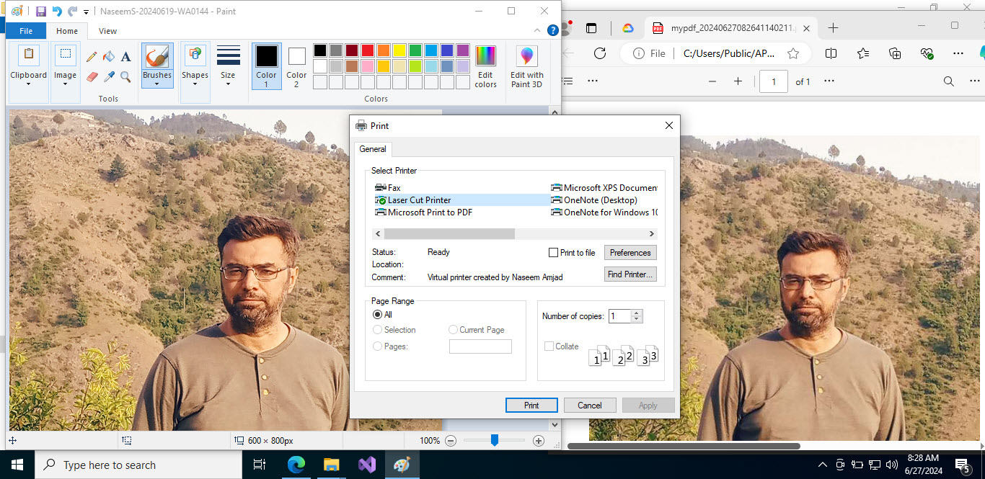

Medical Imaging / EEG Analysis (Python)
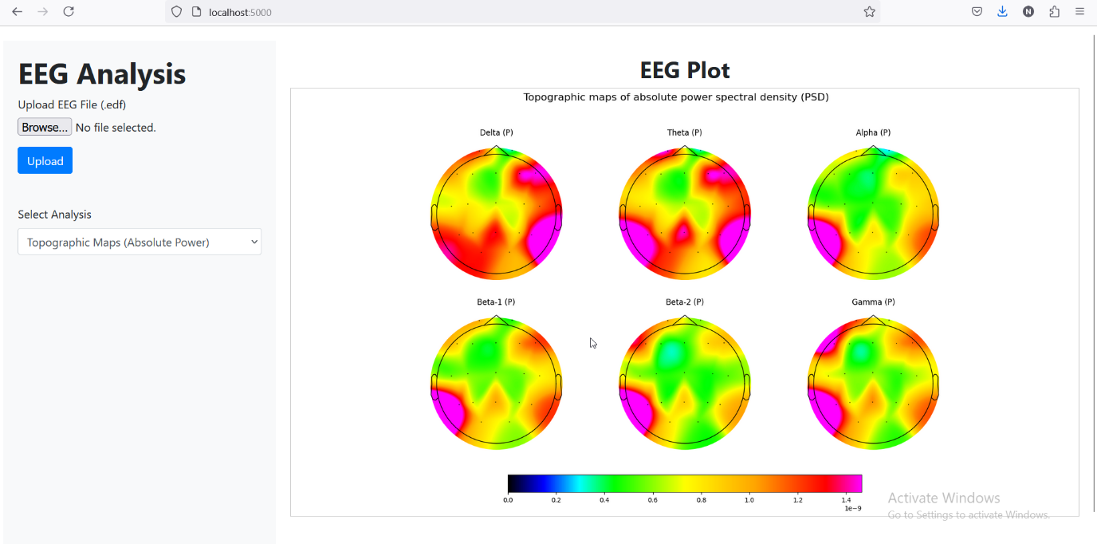
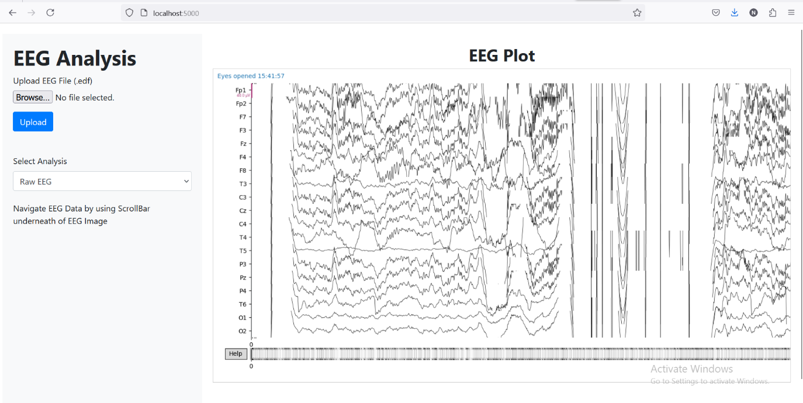

Laser Cut Software (Java, C#, C++, NSIS Installer)
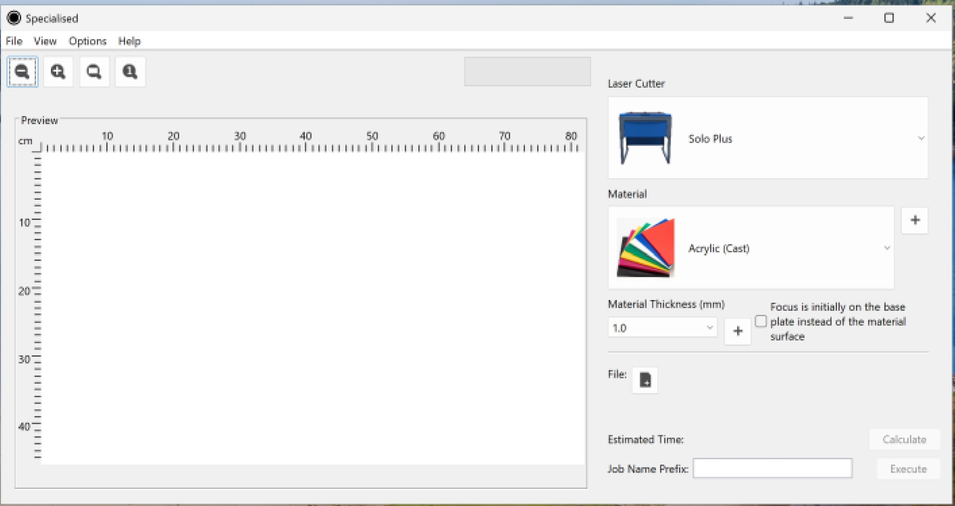
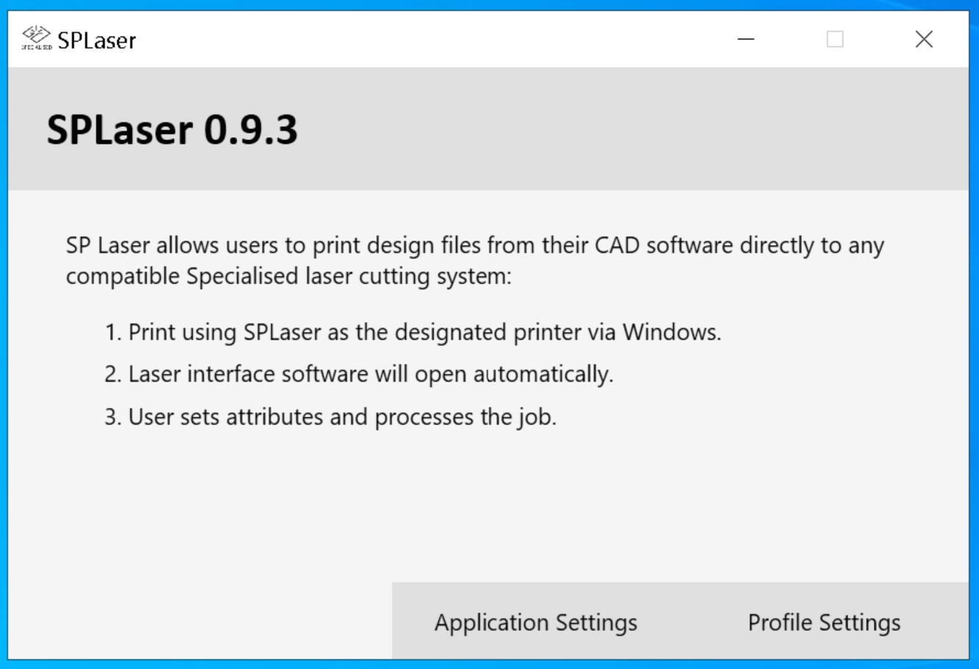
Web Site Migration from Shared Host to Cloud (AWS , WordPress)
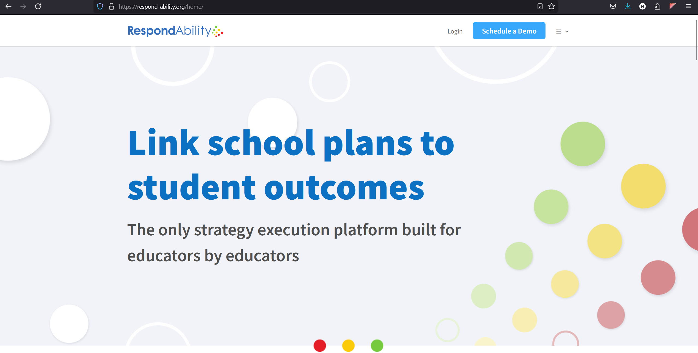
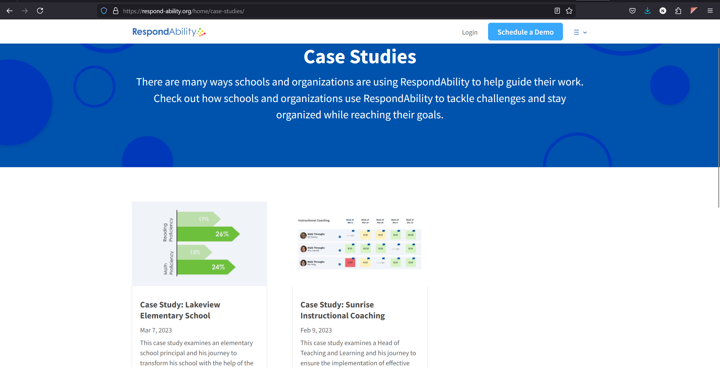
Medical Audit Management System (PHP, Laravel, MySQL)
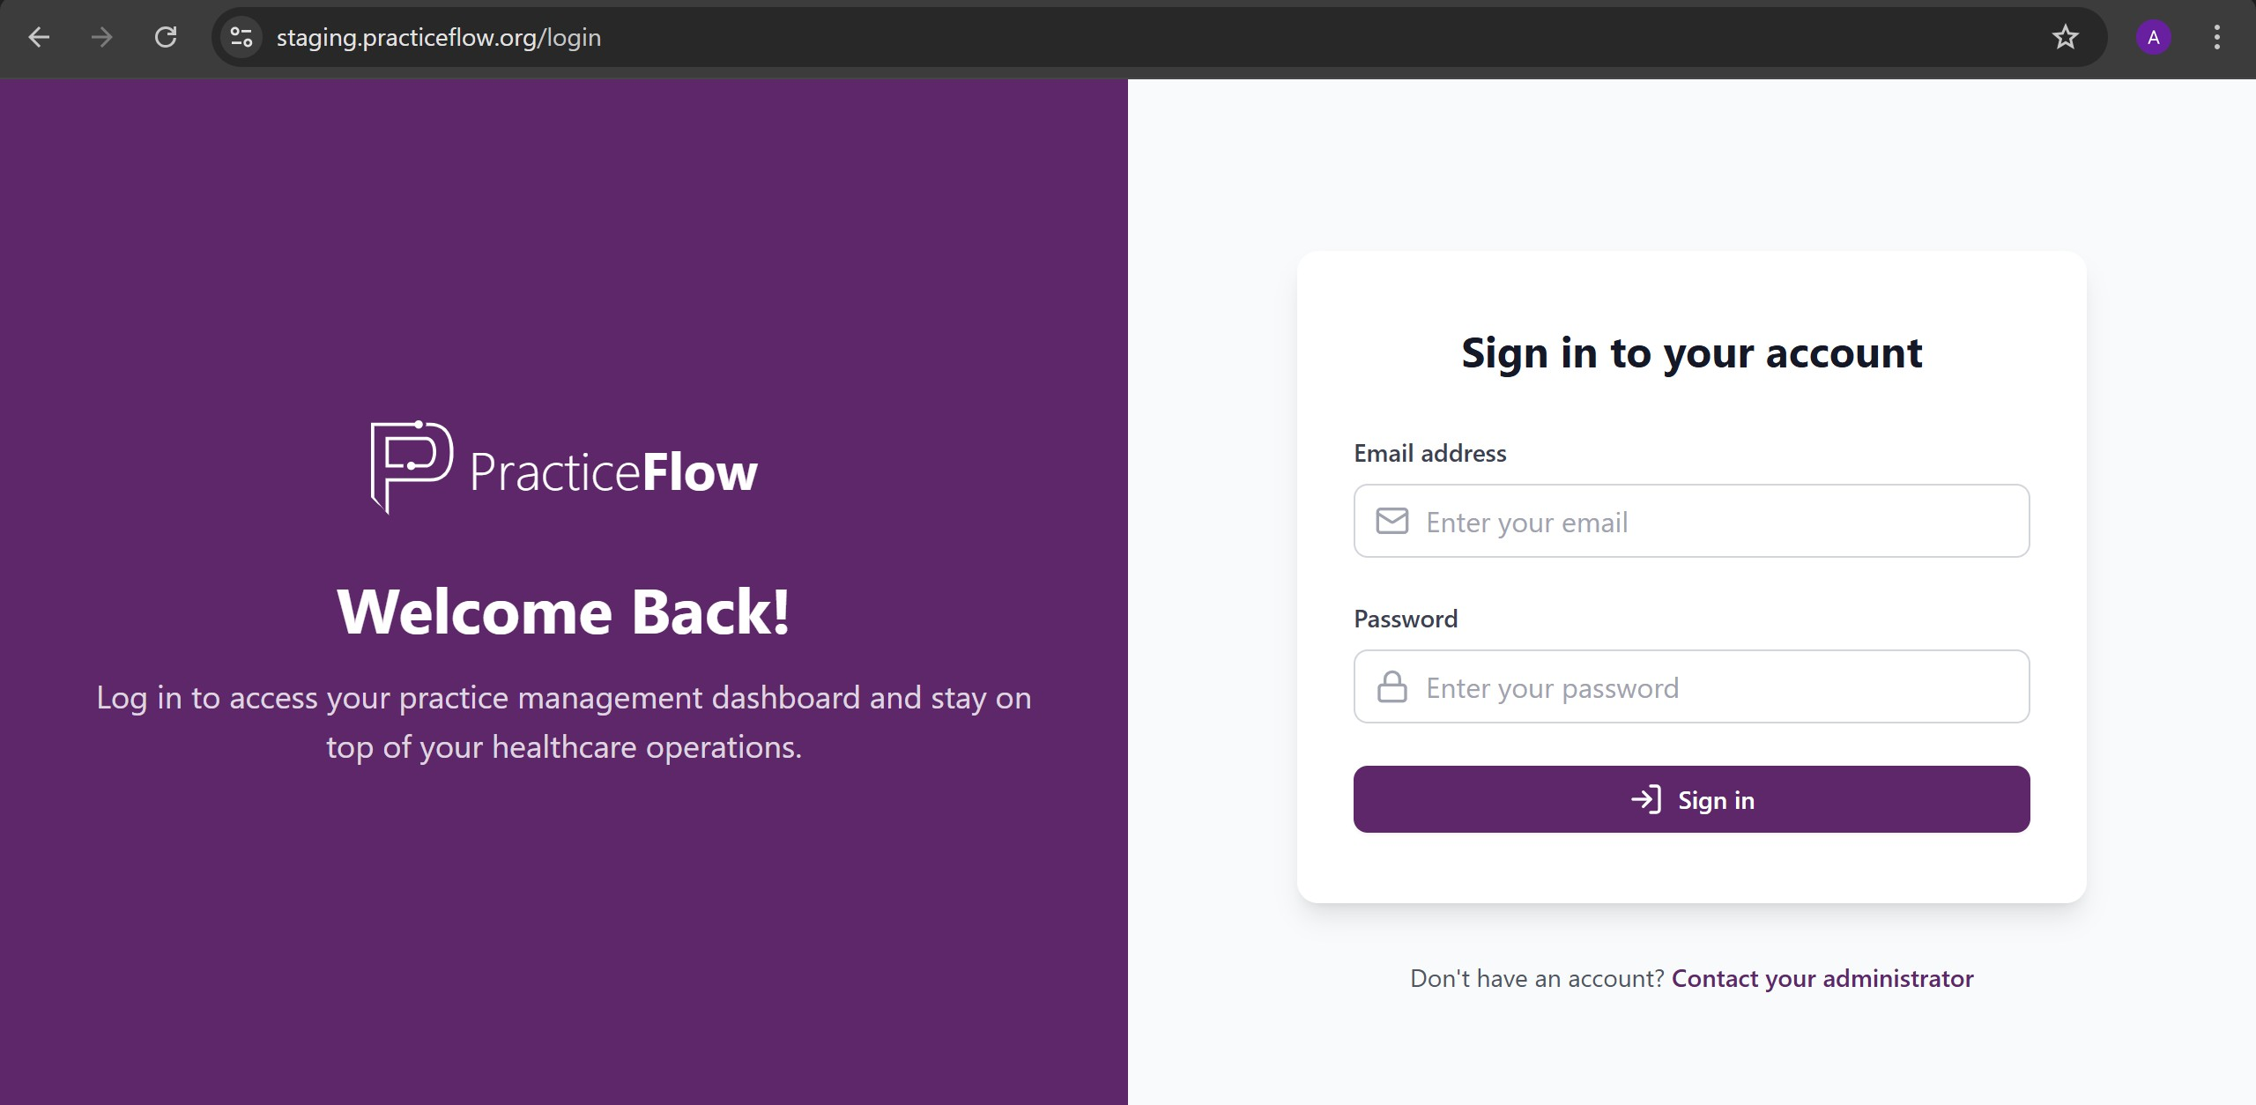
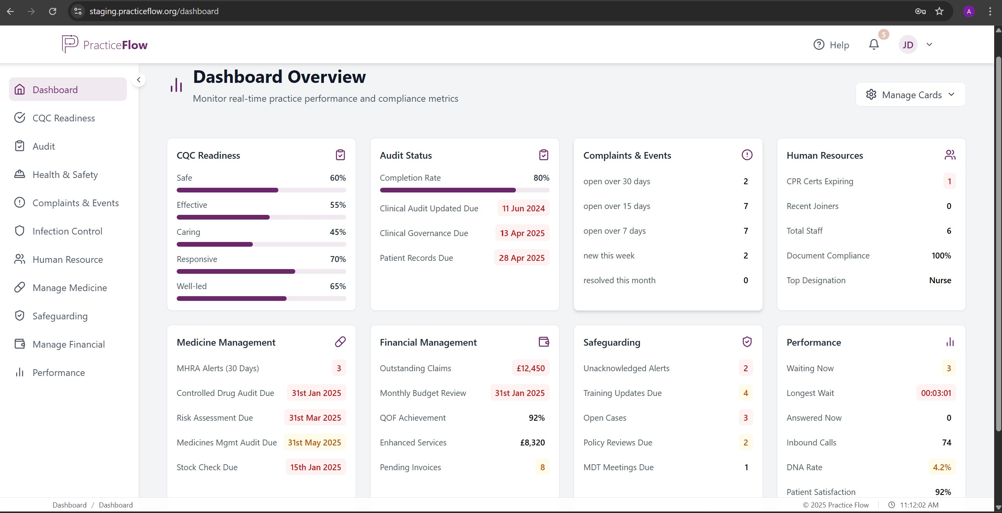
eCommerce Website Development & Management (WordPress, Woocommerce, MySQL)
